UPCOMING EVENTS
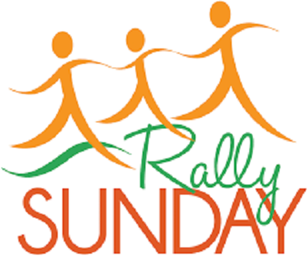
AT FIRST UNITED CHURCH

Sun., Sept. 8 – RALLY DAY @ FIRST CHURCH (see announcement below)

Worship @ 10:30am – Join us after the service for ice cream!

Everyone welcome!
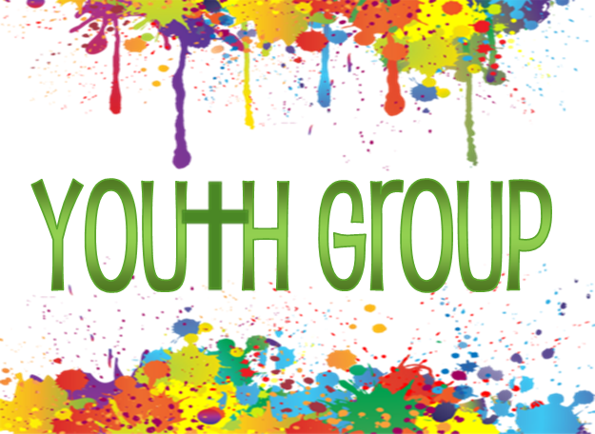

Tues., Sept.10 - FIRST YOUTH GROUP 7:00-8:15pm
Grades 5-12 with Chris Ross
All welcome! Come join us!

Tues., Sept. 10 OFFICIAL BOARD MEETING @ 7pm

Thurs., Sept. 12 - SENIOR CHOIR @ 7:30pm!

Don’t be shy – singing’s great for the soul – come and give it a try!
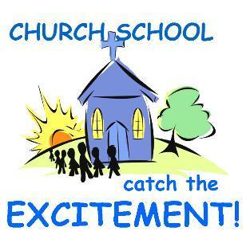
Sun., Sept. 15 – WORSHIP @ 10:30am Guest Speaker: Kevin Abell
CHURCH SCHOOL RESUMES! (see announcement below)

Sun., Sept. 22 – WORSHIP @ 10:30am Guest Speaker: Helen Keenliside

Thurs., Sept. 26 - Elgin Theatre Guild presents Sandy Toes and Salty Kisses at the historic
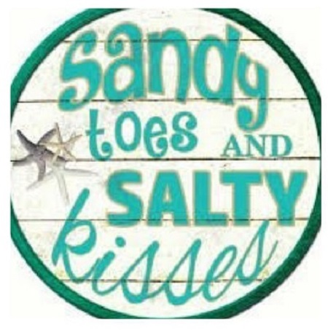
Princess Ave. Playhouse. Tickets can be purchased for this date through First United Church for $20, with $8 from every ticket sold going back to the church! This is a great opportunity to invite friends, family and neighbours for a fun evening out, and raise money for First! Tickets are available through the church office.
Here is a brief summary of the play: Event type: All Ages / Licensed
A play full of mistaken identities and a mix up of room numbers this
fantastic play will have you wondering what on earth could go wrong
next. The Lovers Landing Beach Hotel on the Gulf of Mexico has been promoted as “The home of Sandy Toes and Salty Kisses:” becoming a popular wedding destination. Mayhem ensues when the eccentric Wedding Planner, Madame CoCo, suddenly elopes leaving the position vacant to be filled by the owners Uncle Bubba who is actually the Handyman. When Beatrice Rutherford-Smythe arrives with her daughter to check out the place, things start to go awry. With unlikely encounters and total chaos. Will love win through?

Sun., Sept. 29 – WORSHIP @ 10:30am Guest Speaker: Janine Lunn

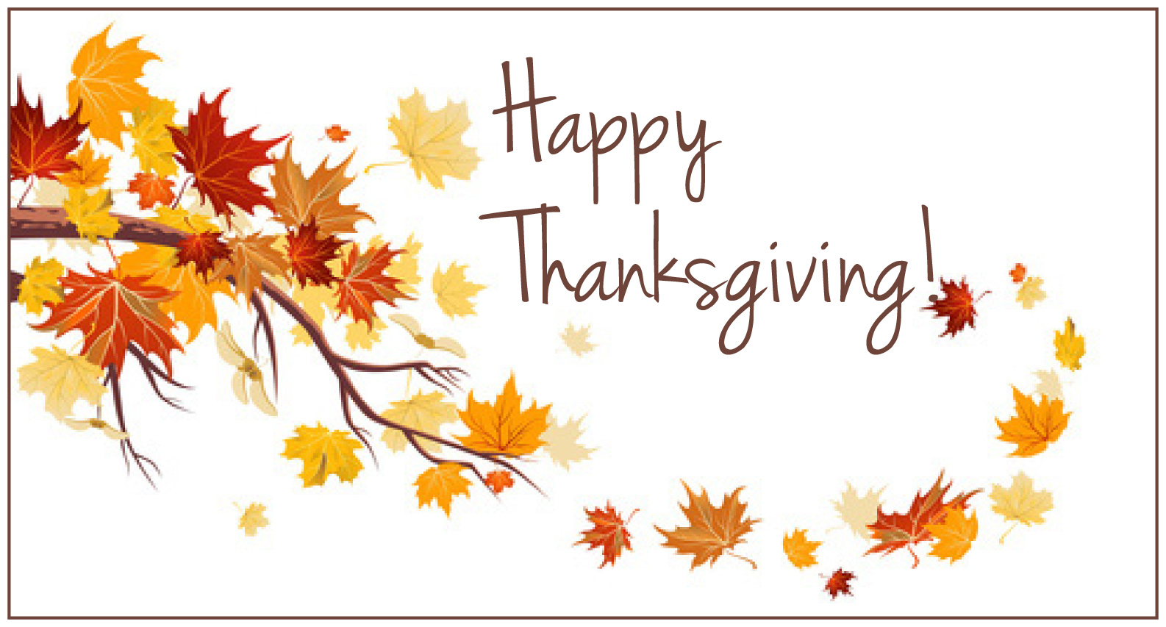
Sun., Oct. 6 - WORSHIP @ 10:30am Guest Speaker: Justin Dimoff

Sun., Oct. 13 THANKSGIVING SUNDAY (see announcement below)

Sat., Oct. 19 – RUMMAGE SALE 8:30 – 11:30 am

We hope EVERYONE will take some time in the next few weeks to clean out
their closets, attics and basements and donate your gently used items to our
sale! Looking for fall and winter clothing, special ladies wear for our
popular boutique, shoes, boots, hats, mittens, china, glassware, vintage
items, fall and Christmas decorations, jewellery, luggage, small household
items (please no TVs, microwaves or computers), books, games and toys.
Donated items may be left inside west accessibility door Mon. - Thurs.
9am-2:30pm. Please call Lois Whiteman 519-631-3337 if you are able to
help sort and price the weeks before the sale or if you would like to work
sale day. Thankyou!

Later in October – FIRST CHURCH BOSTON PIZZA NIGHT - Date to be confirmed

Sunday, Sept. 8

RALLY DAY

A TIME TO RALLY TOGETHER AFTER THE SUMMER!
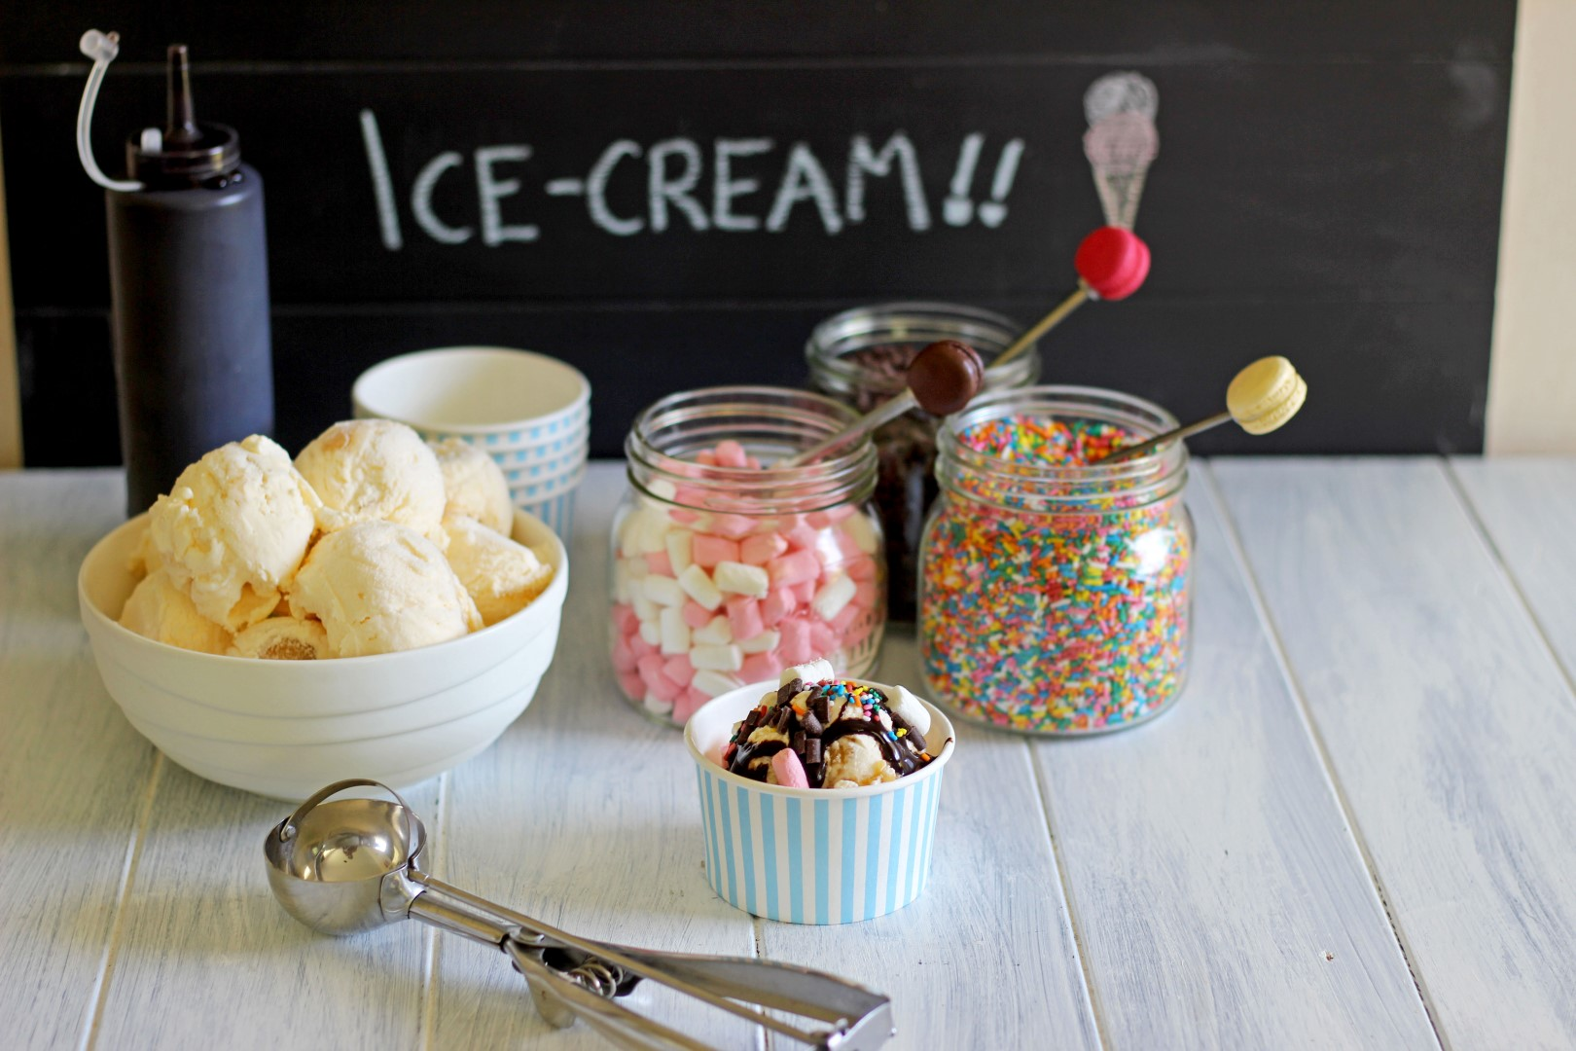
We’ll all be in worship together younger and older
alike because that’s
who we are!

STAY FOR ICE CREAM

AFTER THE SERVICE!

Come and catch up with First Church Family & Friends!
Everyone Welcome!

* * * * * * * * * * * * * *

CHURCH SCHOOL RESUMES
Sunday, September 15!
The teachers look forward to welcoming
the children and young people back to Church School.

THANKSGIVING SUNDAY
October 13
God has blessed us, as a community of faith,
that we may be a blessing to others.

Once again, we invite you to bring
GIFTS OF HEALTHY FOOD
for those who do not have enough!

From the fields & orchards:
Potatoes, squash, turnip, brussell sprouts, apples,
beets, cabbage, carrots, oranges, onions, corn on the cob.
(foods with a little staying power)
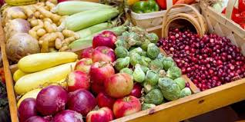

From the grocery store:
Healthy canned goods (low sodium),

spaghetti & tomato sauce, beans, lentils, tuna, salmon, soup,
juices, mac & cheese, peanut butter, coffee, tea, sugar, crackers
peanut butter, dry pasta, rice, salt, pepper,
Cereal and hot cereal, granola bars, etc. for lunches,
garbage bags, saran wrap, sandwich bags.
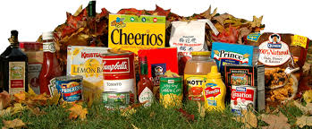

Personal Hygiene Products:
Tooth Paste, dental floss, hand soap, shampoo, conditioner, deodorants sans aluminum, dish soap, laundry detergent, toilet tissue, razors, diapers, baby lotion, and

Women’s Hygiene Products

“THANKSGIVING, AFTERALL, IS A WORD OF ACTION”
W.J. Cameron
ONCE AGAIN, FIRST CHURCH WILL BE HOSTING A BOSTON PIZZA NIGHT!

Date to be confirmed – will be later in October

A great ‘fun’raiser for the church.
Cost is $20 per person –
but $10 of that comes back to the church.
An opportunity to visit and best of all – NO CLEAN UP!

THE BUFFET includes: Pizza, Pasta and Caesar Salad
(drinks not included)
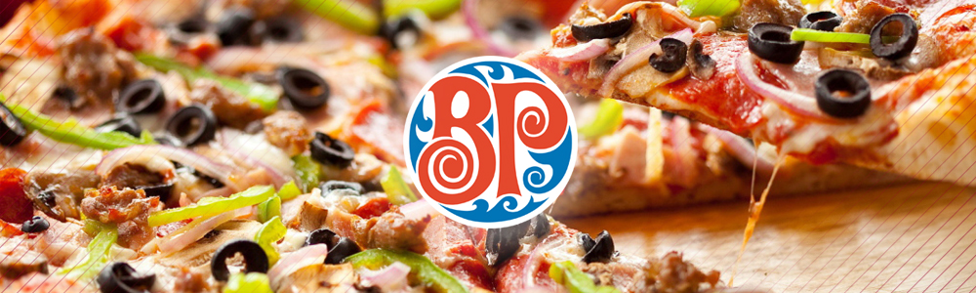

DOOR PRIZES too!
Be sure to write your name on the back of the ticket
before you turn it in at the restaurant.
Tickets will be drawn that night!
Children can order from the ‘Children’s menu”
instead of paying $20 for each child.

Tickets/ more information will be available soon!
Bring a friend or two! It’s a great & affordable evening out!

