First With The News
Spring / Summer 2019 Edition

First United Church
Seeking to be a welcoming community of Christian faith,
proclaiming and celebrating the love of God in Jesus Christ
through the Inspiration of the Holy Spirit.

Delivered by: ______________________________________________________

Please visit our website! www.1stunitedchurch.ca

UPCOMING DATES & EVENTS

March
Sunday, March 31 - *First’s 185th Anniversary Celebration (pg. 6)

April
Saturday, April 6 – 3rd First United Church “Retreat” from 9am to 12pm. All Official Board Members are asked to attend, and this event is open to any interested congregation members.

Saturday, April 13 – *First Church & Friends Artisan & Vendor Market – 10am to 2pm (pg. 8)

Sunday, April 14 – *Palm Sunday (pg. 7)

Thursday, April 18 – *Maundy Thursday Worship Service @ 7pm (pg. 7)

Friday, April 19 – *Good Friday Worship Service @ 10:30am (pg. 7)
*The Senior Youth Group will be attending “The Swell” at Wesley Knox United Church in London @ 7pm (pg 9)

Sunday, April 21 – *Easter Sunday Worship Service @ 10:30am (pg. 7)

Monday, April 22 – *Easter Monday/Earth Day – Church Office is closed
*Youth Groups will be participating in an Earth Day Clean Up! (pg. 9)

Saturday, April 27 – *Spring Rummage Sale from 8:30-11:30am (pg. 10)

Sunday, April 28 - *El Sistema Concert at First @ 2:30pm (pg. 11)

May
Saturday, May 25 - *Mom-to-Mom Sale from 9am to 1pm (pg. 12)

June
Sunday, June 2 - *Rosemarie Johnson-Clarke will be presenting a Puppet Show for the Sunday School (pg. 13)

Each Thursday in June (6, 13, 20, 27) the CD Committee will be presenting a “Parenting on Purpose” Movie Series @ 7pm (pg. 14)

Sunday, June 9 - *Ice Cream Sundaes after Church! (pg. 13)

Sunday, June 23 - *CD Sunday Worship Service @ 10:30am. Worship will be led by the youth. BBQ to follow. (pg.13)

Sunday, June 30th – Faith Activity Room Starts

August
Monday, August 12 – Thursday, August 15- *Vacation Bible Camp (pg. 13)

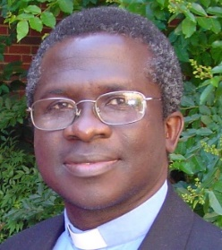
From the Pastor’s Desk …

T

ime passes by so quickly that we don’t normally notice it and the
past year has not been an exception. I am now in my second year
at First United. The past year was very exciting for my family and
me and has offered us both opportunities and challenges. We have had the privilege of knowing more about life in St. Thomas. We have made new friends and formed new bonds of relationships; our horizon has expanded, we have been enriched immensely and we hope to increase in knowledge and in relationships as we journey together.

The journey has been full of excitements and challenges. My family has come a long way as we seek to understand both the church and society better each day – we are still in the learning process. Our pastoral relationship in the past year reflects what I may describe as the tale of mutual adjustments. It’s been a journey on which we all as fellow sojourners learn together and make the necessary adjustments as we move along.

We are in lent now. In our meditations, we have paused for Sober Reflection. We have been reminding ourselves of the need of taking time to meditate on what our Lord Jesus Christ went through before He reached Golgotha. Since Ash Wednesday, we have been looking at Haddon Robinson’s booklet, JESUS’ BLUEPRINT FOR PRAYER: APPLYING THE LORD’S PRAYER TO YOUR LIFE. Robinson reminds us of how the disciples of Jesus, despite all they heard and saw from the Saviour, they still wondered about something we often struggle with today – how to pray. The author of the book encourages that “if Jesus’ closest friends weren’t ashamed to seek His help with prayer, then we as His modern-day followers should not be afraid to do the same”. So for our Lenten journey we want to explore questions like “How do we pray? What should we say? Who do we address our prayer to?” and many more.

As we seek to apply the Lord’s Prayer to our own lives, we come face-to-face with ourselves, leading us to evaluate our own selves. Most of the time, Self Examination can be a painful experience. What we reflect on becomes a mirror through which we see ourselves from God’s point of view. In most cases, we become aware of our spiritual condition and the poverty of our worship. It brings us face-to-face with the spiritual reality of our hearts; that the heart of the human problem is the problem of the human heart (Jeremiah17:9). At times we may feel that we “have been weighed on the scales and found wanting” (Daniel 5:25-28).
Such realizations may change the way we look at things in order to see things from God’s perspective. What we find may be quite scary; we may cry, “Woe to me!” (Isaiah 6:5) – we have fallen below God’s standard.

This could be a very humbling experience, but the good news is we receive Spiritual Redirection after genuine reflection and sincere self-examination. After all, there is Easter after Good Friday! We begin to understand the meaning of what Jesus said on the cross, “Father, forgive them”; it becomes meaningful to us. We receive forgiveness, assurance of salvation and hope in the finished work of Christ as guarantee to live in newness of life unto God. We change from self-centredness to Christ-centredness; we receive the sunshine of Easter and rise from the dead – our former way of doing things is gone. New direction has begun, and the Spirit of Christ leads us.

As we journey with Christ together, we want to make sacrifices in order to devote ourselves to prayer, “fast” or give up some of the things we love to enjoy most – cups of coffee or tea, candies, chocolate and anything that is pleasurable. At the end of Lent we want to bring all these sacrifices as special EASTER OFFERING to show our appreciation and love for the One who journeys with us in our joys and pains, even the Risen Christ who lives and reigns forever and even, AMEN.

We don’t want to lose what we have gained and for that reason, we hope to continue in our learning process – a continuity that will sustain us on our spiritual journey. Our Wednesday Bible studies will continue after Easter to give us continuous nourishment for the soul. I encourage you to avail yourself to this opportunity to prepare you for the challenges ahead.

Hannah and our children join me to wish all a Happy Easter

Keep the faith and spread it gently.

I am your pastor and friend,

Rev. Emmanuel K. Ofori

First United Church is celebrating 185 years! Join us!

Anniversary Sunday - March 31st
10:30am

Our Former Minister, Rev. Don Parsons
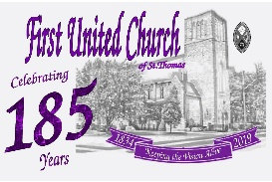
will be our Guest Speaker.

There will be lots of special music.

Lunch will follow in the Assembly Hall,
and of course there will be birthday cake!

Everyone is welcome and encouraged to attend!

If you have one of the small bells that was cast from the bell that fell from the tower during the fire, please bring it with you for this special Sunday – we will be ringing them during the service.
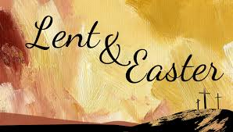

LENTEN STUDIES:
Lent is a journey – one of sober reflection, self-examination and spiritual renewal. We invite you to come journey with us to explore the Lord’s Prayer – Jesus’ blueprint for prayer. We want to discover together how to apply the Lord’s Prayer to our lives. Wednesdays @ 7:00 p.m. in the Fellowship Hall.

HOLY WEEK
An invitation to stop and get quiet in God’s presence in Holy Week. In these troubled and unsettling times, we all experience sorrow, frustration, confusion, and often helplessness at the horrors on our doorsteps and across the world, seemingly delivered daily through our TV screens in recent weeks and months. We invite you in this holy week to do something beautiful for those caught up in troubles, for your loved ones, for yourself and for God. Stop, quieten, pray in church, and/or join us at our worship services as follows:

Palm Sunday.
We relive and proclaim Jesus’ triumphant entry into Jerusalem with the palm processional at our worship service on Sunday, April 14 @ 10:30 a.m. Come celebrate with us.

Maundy Thursday
On this night Christians commemorate the foot washing and last supper Jesus shared with his disciples before his crucifixion. Come and dine the Lord is calling. Join us on Thursday, April 18 @ 7:00 p.m.

Good Friday
This service commemorates the crucifixion of Jesus Christ and his death at Calvary. Come reflect on the seven statements Jesus made on the cross Friday, April 19 @ 10:30 a.m.

Easter
We proclaim, “Christ Is Risen” through word and music. Join us on Easter Sunday, April 21 to rejuvenate after the cold winter months as we celebrate “The Risen Christ, Our Hope & Joy in Hard Places”. The Senior Choir will participate in the service.

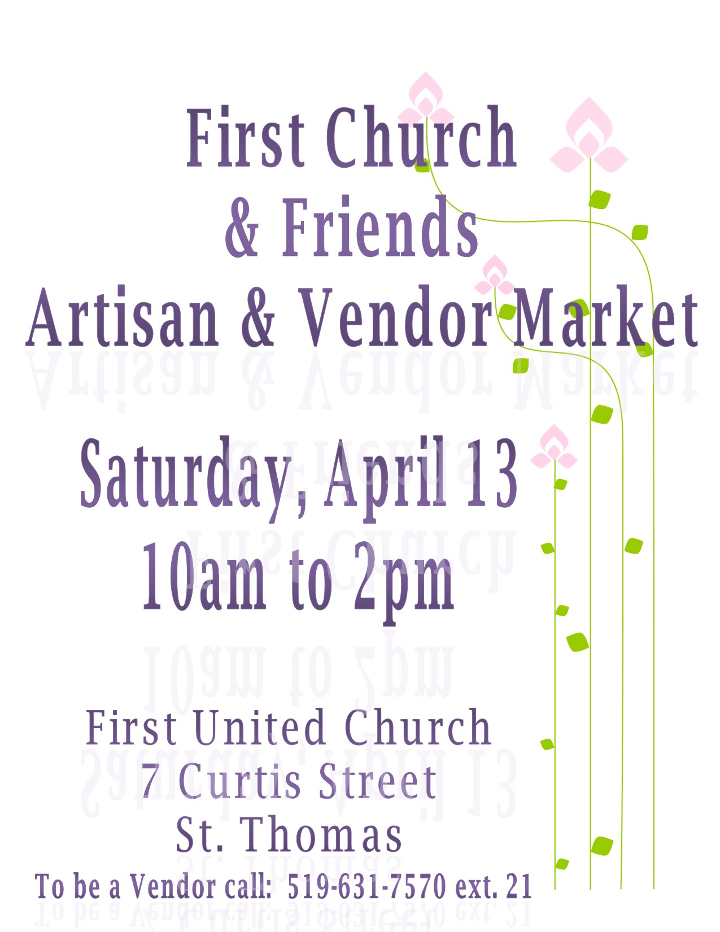

Youth Group

The Senior Youth Group will be attending
The Swell at Wesley Knox United Church
on Good Friday (April 19) @ 7pm.
Contact Chris for more information!

Monday, April 22 is Earth Day!
Our Youth Groups will be participating in an
Earth Day Cleanup!
All are welcome to come and “pitch in!”
(Time TBA – watch for further details)

Our Youth Groups meet:
Senior Youth: Grades 8-12
Every Thursday 7:00 – 8:30pm
Led by Chris Ross

Junior Youth: Grades 5-7
Every other Thursday 7:00 – 8:30pm
Led by Justin Chute, focusing on Outreach.
(Ideas welcome!)

Last regularly scheduled Youth Group meeting will be April 25th.
Events will occur over the summer – communication will be emailed.
Fall program will start the first week of September.
SPRING RUMMAGE SALE
Saturday, April 27
8:30 – 11:30 am

Our Spring Sale is fast approaching! It’s the perfect time to bring in all the treasures you no longer need at home…Or purge your closet so you have room to buy some new spring outfits!!

We’d love to have your Spring & Summer clothes (in good condition!) No computer parts or electronics please.

SORTING & PRICING HELP NEEDED! If you have an hour or two you can spare we’d appreciate the help! Join us in the gym @ 9am Wednesday, April 3 & 10 or the week of the sale Tuesday, April 23-Friday, April 26.

MEN NEEDED FOR SETUP on Tuesday, April 23 @ 8:30am
Also CLEAN UP HELP NEEDED on Saturday, April 27 @ 11:45am.

Thank you for your support!

*Thank you to Mike Muma for organizing the kitchen clean up with helpers, Bill Beamish, Mark & Vicki Snowsell, and Don & Jacqueline Renaud.

*Thank you to all those who helped at and attended the Pancake Supper!
$421.35 was deposited to the General Fund!

First United Church
is hosting a concert to support

Sunday, April 28 at 2:30 p.m.

El Sistema is a world-wide program,
that selects youth and nurtures their personal development and talent through free instruments and instruction.
This program has begun in St. Thomas this past October.
There will be other musicians from our community performing along with the double quartet of advanced string players and the junior group that has begun in St. Thomas in October 2018 at
Locke’s Public School and Monsignor Morrison Catholic School.
The Board and congregation of First United are pleased to support this endeavor as a part of our celebration of our 185 years
as a congregation in St. Thomas.
Please come to support El Sistema South London/St. Thomas!!

Tickets are available through the Church office for $10 (call 519-631-7570).
If you require any further information on El Sistema
feel free to visit their website www.esslondon.ca.

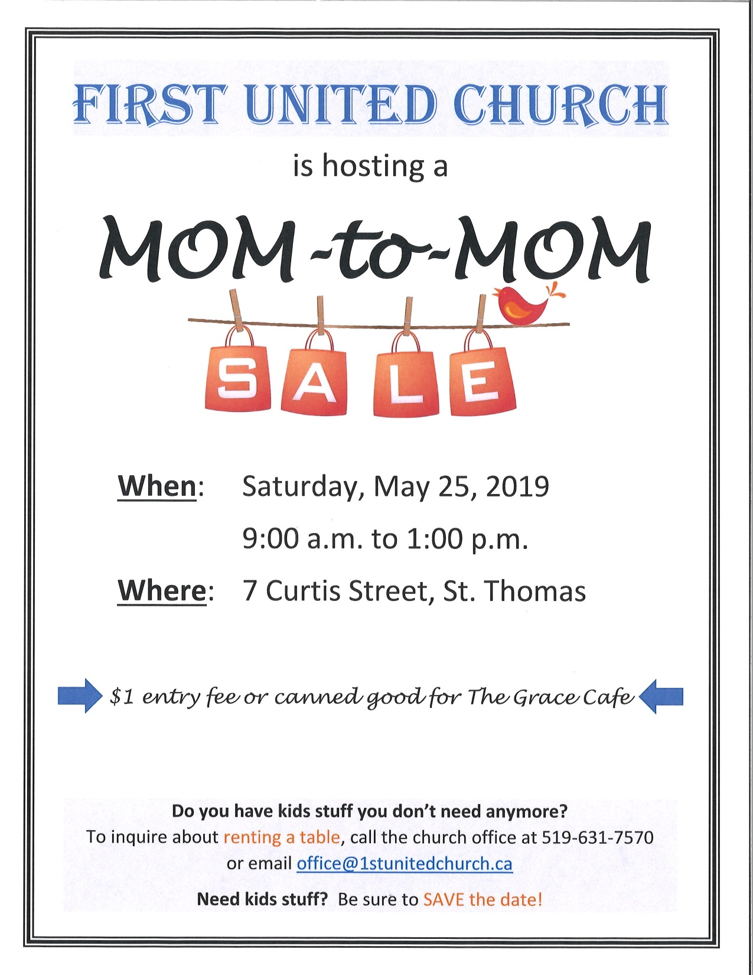

From the CD Committee
We have some great events coming up so mark your calendars!

*Each Thursday evening in June the CD committee is hosting a movie series called “Parenting on Purpose” with Mark Hughes from the Church of the Rock. Anyone who is interested is welcome to attend!
(Full details on next page!)
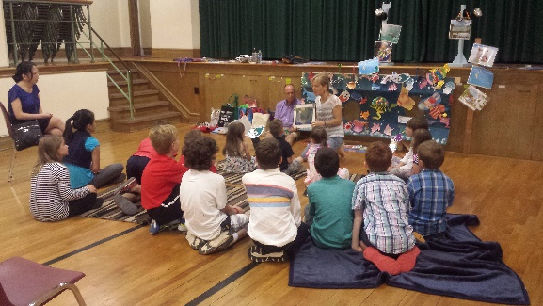

*June 2nd – Rosemarie Johnson Clarke
will be doing a Puppet Show for the
Sunday School classes.

- June 9th – Ice Cream Sundaes after church. All welcome!

*June 23rd – CD Sunday
- Service will be led by the youth
- BBQ to follow service

*June 30th – Faith Activity Room starts

*August 12-15 – Vacation Bible Camp.
Registration will be open in April.
(note that this will only be a 4 day camp this year!)
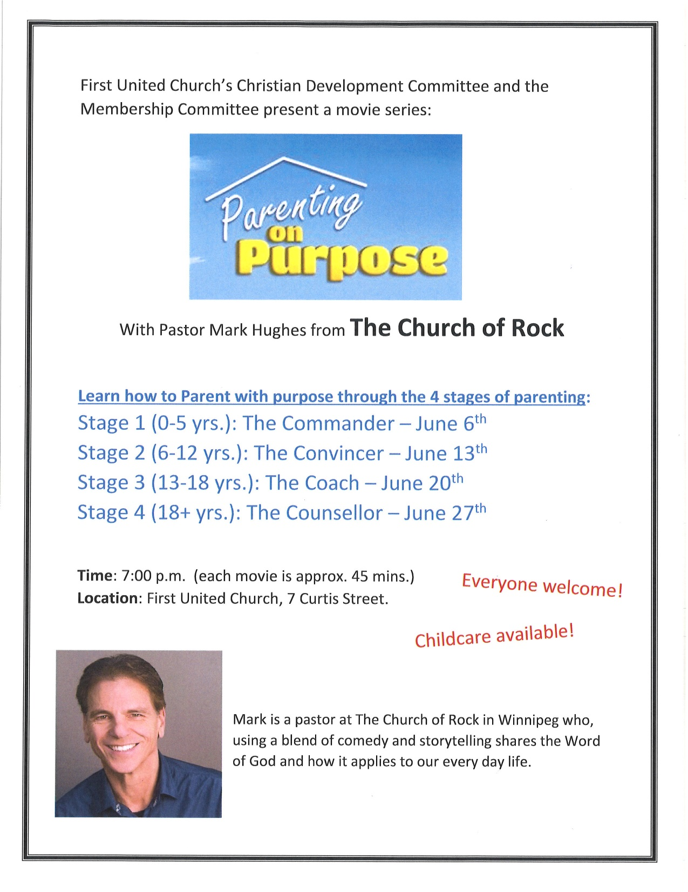
From the Official Board
On Friday, March 8, at the request of the Ministry and Personnel Committee, Regional Council staff facilitated a ‘restorative practice circle’. At the recommendation of Regional Council, various members of the Official Board, representing all committees, our Minister of Music Jody McDonald-Groulx and our Pastoral Minister Emmanuel Ofori were invited to participate in this circle. Retired minister, Bob Gibson also joined the circle to support Emmanuel. Kim Uyede-Kai, Minister of Right Relations and Diane Blanchard, Minister of Pastoral Relations, both from our newly formed Regional Council were there to facilitate and record the meeting.
“Restorative practice” is a phrase that lifts up a model for all church communities to practice and keep practicing ways of restoring relationships to be right with God and each other. This model for faith communities is based on well-respected international restorative justice principles.
The intention of the restorative practice circle is to create a safe, spiritual space without shame or blame and
- where each person can speak openly and bravely in a gentle and respectful way about the issues at First United Church and its current pastoral relationship, and
- where healthy faith community relationships can be restored.
Each participant had an opportunity to speak uninterrupted, and provide their perspective on the challenges that First United faces and how this has affected us and the people around us. Some themes that came forward were:
- a sense of grieving and loss, not only for saying goodbye to Roger and Barb, but also seeing many long-time members choosing to leave
- too much change, and too fast
- an unwillingness to accept change and let go of the past
- fear and panic over declining numbers and finances
- challenges adjusting to a minister with an African accent and different cultural background
- concerns for the wellbeing of the congregation, the staff and for Emmanuel and his family
- challenges accepting a more Bible based, evangelical message
- the length of the sermon may be more than people can absorb
- racism, xenophobia and personal attacks that Emmanuel has faced
- lack of transparency and poor communication
- a negative message about First United being spread in the community, damaging our reputation
The circle then addressed what positive steps could be taken by the Official Board, Emmanuel and Jody to make the church more appealing to the congregation, as well as what can be done to better support Emmanuel.
The Official Board acknowledged much of the congregation was not prepared for Emmanuel’s evangelistic style and Emmanuel was not made fully aware of the needs and expectations of the congregation. It was noted that the job description clearly indicated the desire to have a Bible-based preacher and Emmanuel rightfully applied as such.
It was also suggested that we all need to work harder at establishing the church’s identity and proactively embrace and promote its distinctiveness throughout St Thomas. Are we to become a more traditional Bible-based church, a more progressive people-oriented church or a hybrid that stresses both Christ’s teachings, as well as the need to acknowledge and address changes in life-styles and the issues facing modern families?
The Official Board committed itself to being more proactive in working with Emmanuel to promote the vision of the church and become more active in engaging and listening to the congregation to try to meet their needs. Increased transparency was another goal, which was supported by all.
Jody committed to continuing to do casual Sundays twice a month including the additional music and preparation involved, and also stressed her willingness to be a team player.
Emmanuel offered his willingness to listen to the congregation and consider changes to his approach to preaching the gospel, but reiterated the importance of prayer and Bible studies. He expressed his desire to engage with the congregation and to be available to talk to them. He welcomes open dialogue and encourages individuals to approach him and enter into respectful conversations on their thoughts and ideas. He emphasized his willingness to consider adjustments to his style, but needs constructive feedback to do so.
Finally, it is the commitment of Emmanuel, Jody and the Official Board that we will do everything we possibly can to make our church a place where all of us can worship together as a spiritual family and leave the service each week feeling rejuvenated, loved and feeling closer to God. The Board asks for the help of each member in improving the life of our church. Please bring any concerns, ideas, or complaints to Emmanuel and/or to the Board members, either directly through constructive face-to-face conversation, by phone call, by letter, or by email. If we all work together, we can revitalize our church into a meaningful, flourishing place of worship.
Questions or feedback? Email: personnel@1stunitedchurch.ca
minister@1stunitedchurch.ca

Update: Family & Youth Ministry Coordinator
We are excited about plans to hire a new Family and Youth Ministry Coordinator. A job posting has been in place for approximately one month and several applications have been received – many with excellent resumes! A first round of interviews will be conducted in March. Please stay tuned for more news regarding this exciting initiative!
Personnel Committee
Marisa Tippett – Chairperson, Ray Bosveld, Mark Snowsell
From the Finance Committee
Although financial support is still down, we remain hopeful that, as the congregation embraces some of the new initiatives of the church such as, casual Sundays and cost cutting initiatives, we will be able to reach our financial goals for the year. Let's keep the faith!
The committee is continuing to ask for your support via online donations through PAR/Paypal. Once set up, these donating vehicles provide very efficient, user friendly and cost-saving methods of supporting our church. On March 31st, we will be providing new laminated cards in the pews for use by those families donating via PAR or PayPal. We encourage those of you who have embraced online donations to put these cards in the basket during the Offertory to promote this initiative. Should you need any help in adopting either of these two methods, please contact Lori in the church office and she or another member of the Finance Committee will assist you. Thank you!
Respectfully submitted, Don Renaud, Chair, Finance Committee

Financial Facts
*We started 2019 with a deficit of $16,420.04

*To cover our expenses we need $19,125 per month in General Fund Givings.

*PAR/Paypal Givings contribute $3,449.00 per month to the General Fund
($3,449.00 x 2 = $6,898.00 to date)

*In January our General Fund Givings were: $7,031.00
*In February our General Fund Givings were $8,139.30
*That is a shortfall for the first 2 months of the year of $16,181.70

*As of February 28, 2019 we are at a deficit $32,601.74

Given the operating losses being experienced this year, we respectfully ask each member of the congregation to consider increasing their weekly/monthly contribution. Even the smallest increase would be greatly appreciated and will help your church remain financially sound.
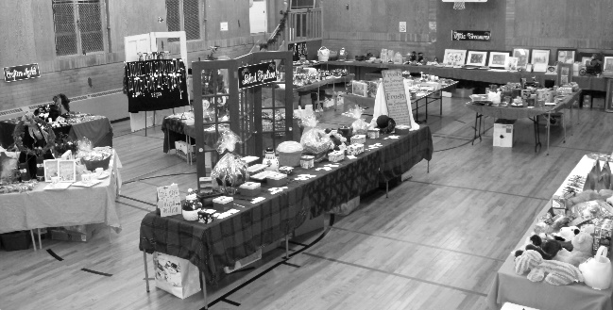

Holly Fair
Report

Well God gave us a beautiful fall day for our Holly Fair with a little nip in the air. I was met with smiles from 30+ anxiously waiting shoppers. It was a moment for me of just thankfulness, blessing and a proud moment of how people in this faith community had come together and had such a positive impact on the community at large. I was so proud of all of you that helped at this event and how you all came together and made this event a success.. all ranges of ages helped ...What a great day.. This event raised $4,700.00 for the General Fund.

A huge thank you to the Holly Fair Team whose support and friendship helped make this event possible. To the staff and volunteers for the many ways you all helped, we thank you. A special thank you to the youth that helped this year. It was great to have you as part of the team.
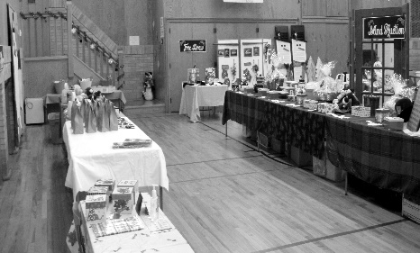
A note from Sherry Johnstone….

For the past few months I have been doing a lot of personal reflecting.
My faith has been a big part of everything in my life, personal, work and my First family.
Since July of last year our First family has been in transition, what do we do, what is going to happen now? Some have been watching from outside these walls, some observing from inside.
We do now have a vision plan……
But ….that plan comes with changes and the unknown. What is our part in all this?
Over the past couple years, I have experienced changes and the unknown..taking me out of my comfort zone. I didn’t really like that feeling…I don’t think other people do either..
4 years ago I stood before you and resigned as Holly Fair convenor but God had other plans and he called me back for 4 more years. After 17 years as convenor, my personal feeling is that the Holly Fair, as it is, has run its course.
As part of the new vision and future of First, it is time for me to be part of not just the new vision plan but of the new action plan. And what is that exactly?
That.. is not obviously clear to me yet…...it is a WORK IN PROGRESS….
As my faith has always been with me on my journey, I know it will be with me going forward, even in the unknown here at First.

I have enjoyed being convenor and working with so many great people on this project. It has been quite a journey that took me in many different directions. What a ride it was…I look forward to working on new projects with my First Family members in the near future as we head in whatever direction God directs us.. our actual destination..unknown…
Have faith...
Sherry Johnstone

Sherry Johnstone, Lois Whiteman

2018 Holly Fair Convenor Team

Special Thank yous:

To those who helped set up and tear down…

Lois Whiteman/helpers.. such a valued team effort

First United staff… Couldn’t have done it without you!

Thank you to Rosemary Underhill for donating her residence,

pots, supplies and getting the greenery donated, to make the arrangements.

Thank you to Lois Whiteman, Sheryl Haaijema, Marlene Smith, Sherry Johnstone, Rosemary Underhill, Judy Upsdell for helping making up the arrangements. GREAT JOB!!
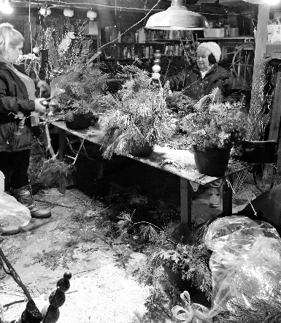

Some highlights of the event:

Audrey’s tea biscuits and pies were back!!!

Mini bazaars after church for 3 Sundays was a

success which added to our profit

Thank you to those who shopped after church.

Great children’s craft and ice fishing in Children’s area

Holly Fair Café – Take out was popular

Silent Auction – successful again.. raised $243.

Holly Fair Team 2018

Karen Auckland/Mary Anne Rayner Holly Fair Cafe

Lois Whiteman Bake Shop

Sharlene Scott Deli

Betty Lou Donaldson Holiday Entertaining

Edith Nimmo/ Sharon Hutchison Book Store

Ruth Zions Children’s Corner
Attic Treasures Treasure TEAM

Sherry Johnstone Crafter’s Market

Sheryl Haaijema Silent Auction/Draw Prizes

Jacqui Travis Finances

Mark Snowsell Parking

Kathy Nicli/Congegation volunteers

Beautiful Overall Decorating

Sherry Johnstone Signs & Bulletin Boards

Vicki Snowsell Publicity

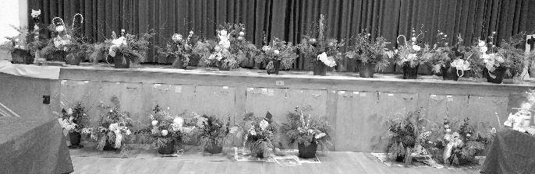

A note from Sherry Johnstone….

For the past few months I have been doing a lot of personal reflecting.
My faith has been a big part of everything in my life, personal, work and my First family.
Since July of last year our First family has been in transition, what do we do, what is going to happen now? Some have been watching from outside these walls, some observing from inside.
We do now have a vision plan……
But ….that plan comes with changes and the unknown. What is our part in all this?
Over the past couple years, I have experienced changes and the unknown..taking me out of my comfort zone. I didn’t really like that feeling…I don’t think other people do either..
4 years ago I stood before you and resigned as Holly Fair convenor but God had other plans and he called me back for 4 more years. After 17 years as convenor, my personal feeling is that the Holly Fair, as it is, has run its course.
As part of the new vision and future of First, it is time for me to be part of not just the new vision plan but of the new action plan. And what is that exactly?
That.. is not obviously clear to me yet…...it is a WORK IN PROGRESS….
As my faith has always been with me on my journey, I know it will be with me going forward, even in the unknown here at First.

I have enjoyed being convenor and working with so many great people on this project. It has been quite a journey that took me in many different directions. What a ride it was…I look forward to working on new projects with my First Family members in the near future as we head in whatever direction God directs us.. our actual destination…unknown…
Have faith...

Regional Council News / Happenings
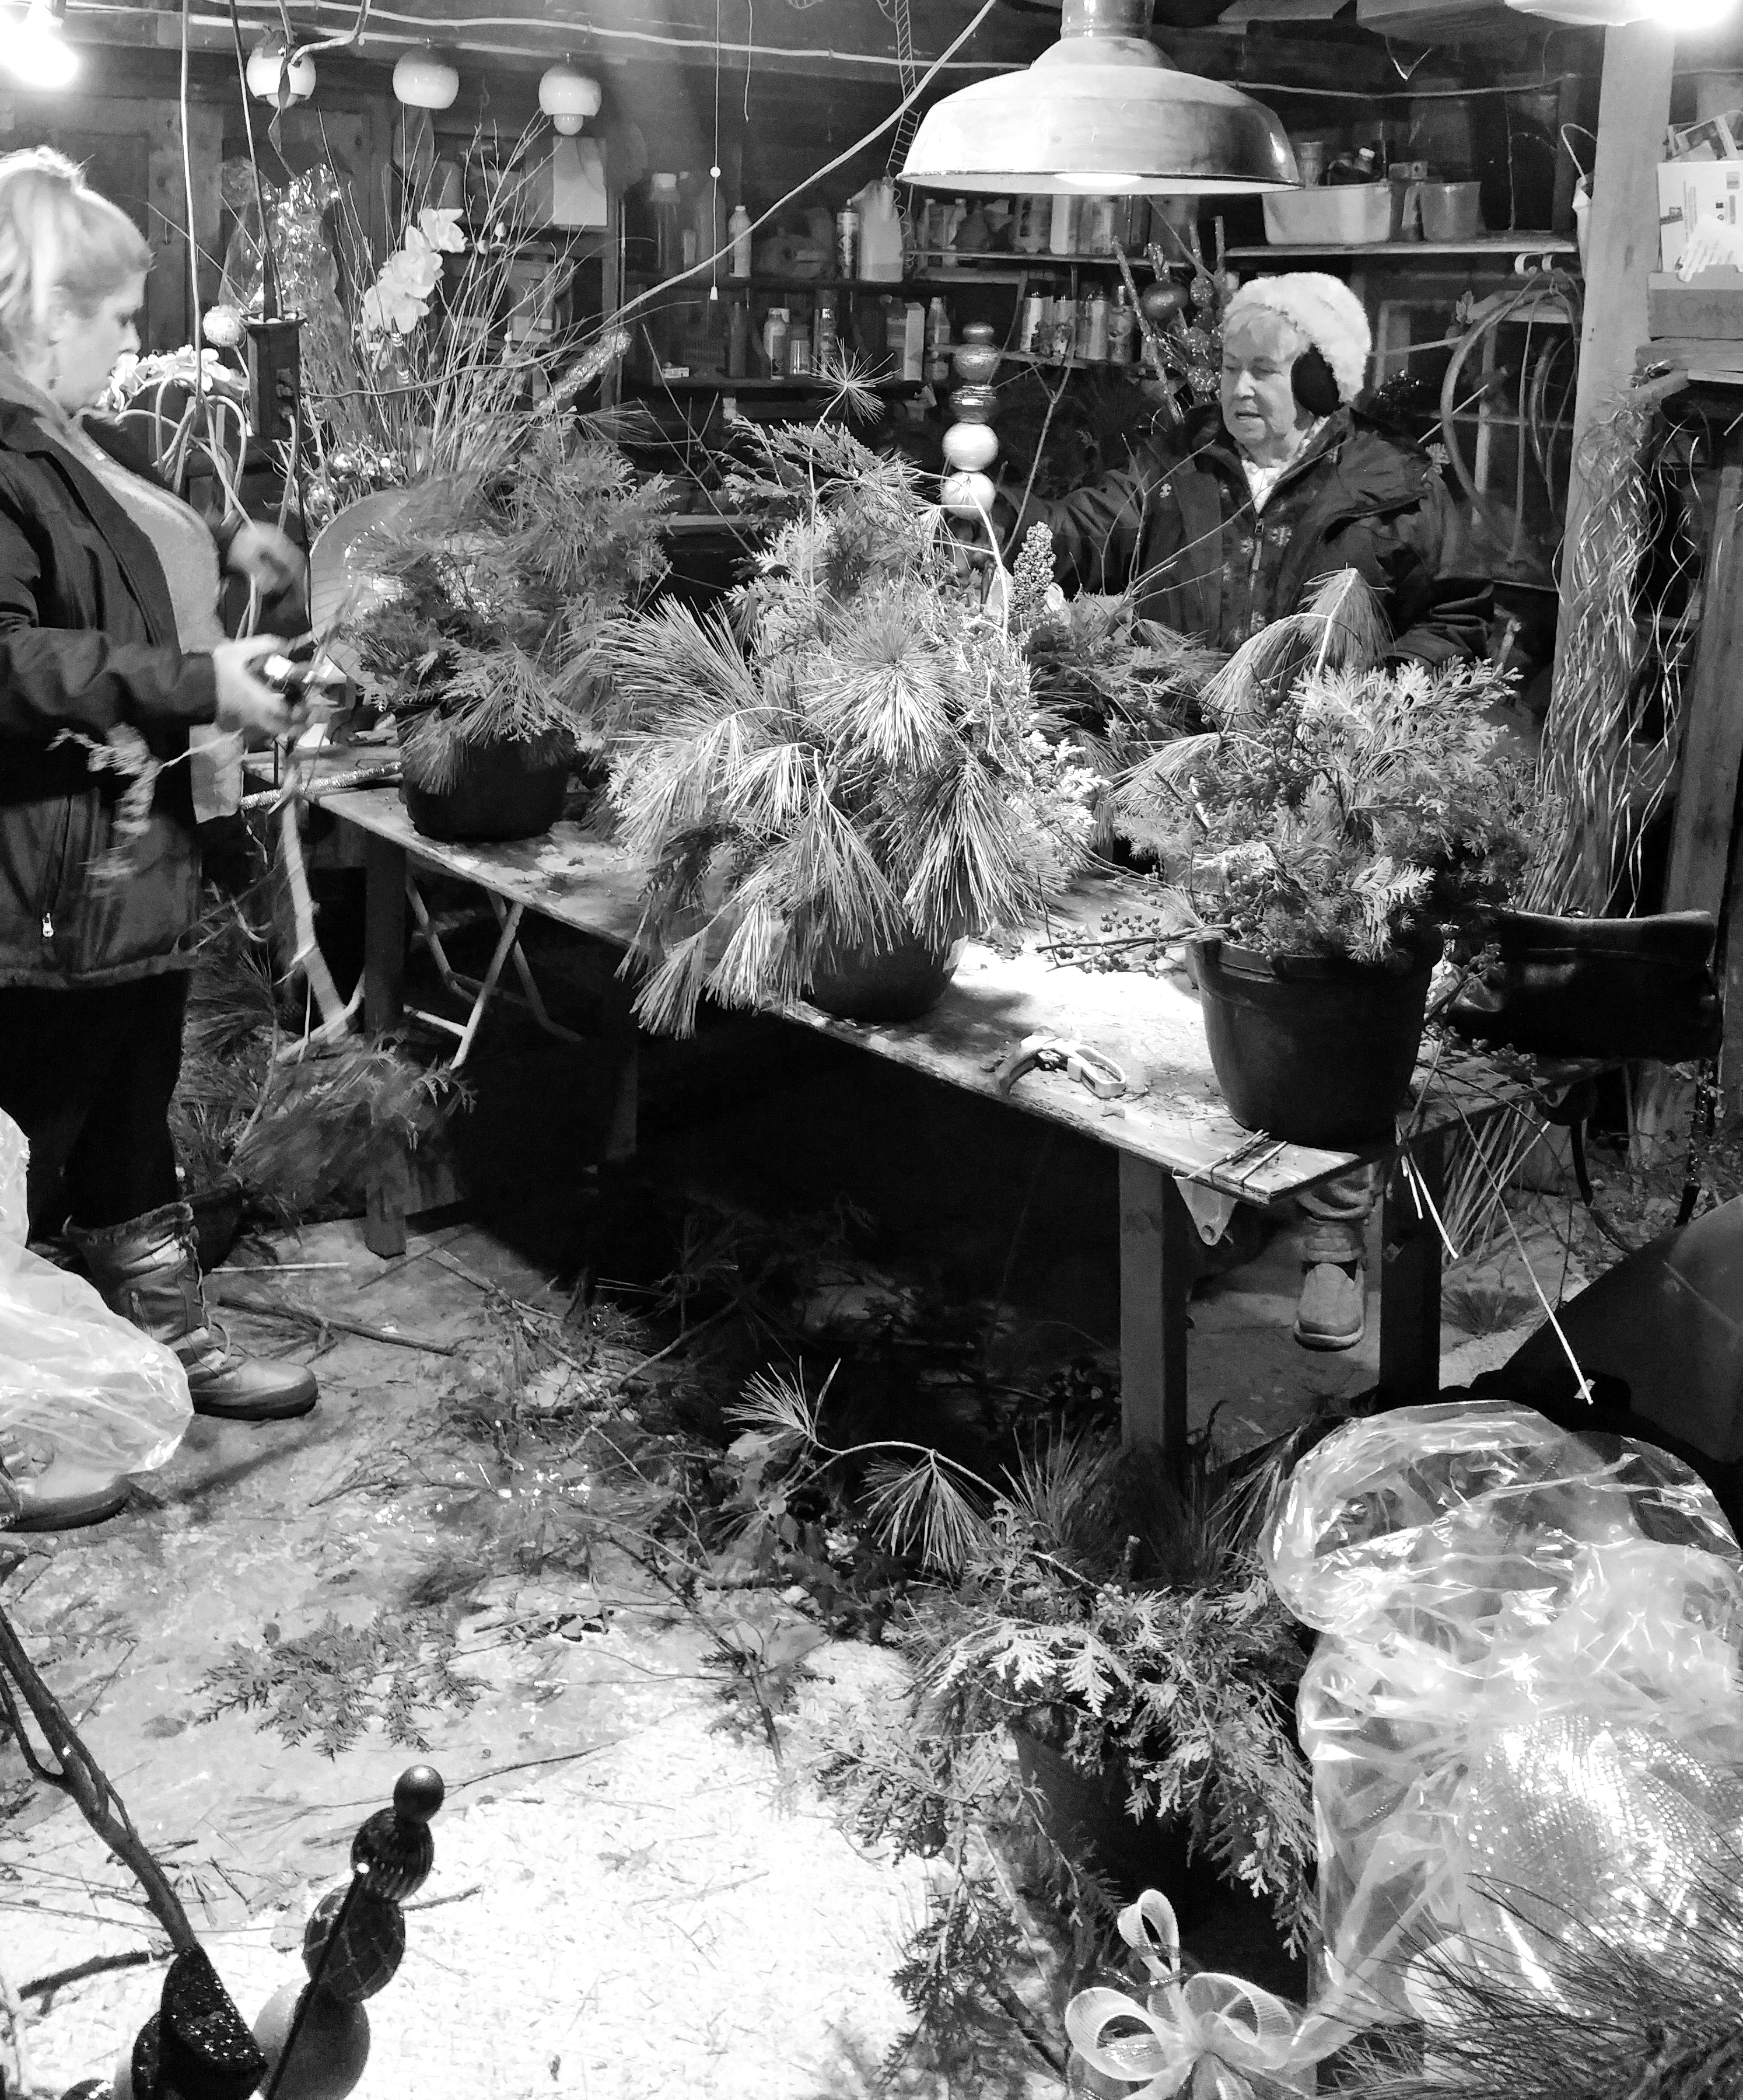
So just what the heck is Regional Council?
For those of you who have been a part of the United Church for some time you may be familiar with the term Presbytery. Well, Presbytery was the body of the United Church that worked directly with congregations. The hierarchy within the United Church was Church Congregations>Presbytery>Conference>General Council. Specifically, for us at First it was First United Church (Official Board)>Elgin Presbytery>London Conference>United Church General Council. With restructuring, The First United Church Congregation now reports to The Antler River Watershed Regional Council and in turn is responsible to the United Church General Council. These first few months have been taken to restructure the Conference Office which has affected staff positions, close local offices, move into the new Regional Council Office in Carlisle near Hamilton and hire new Regional Council staff. At church Annual General Meetings, representatives have been elected to serve on Regional Council. Richard Routhier and I were elected to represent our congregation. As of yet, we have not formally met, and meetings will in all likelihood be held virtually via video conference, but there is a Regional Meeting coming up in Port Elgin in May. We will keep you posted!

Respectfully Submitted,
Richard Auckland
Views from the Pews – Submitted by John Surmacz

“Power Within”

Eph 6:10
I want to remind you that your strength must come from the Lord’s mighty power within you.
I think when we pray, we believe that we pray to some outside spiritual force. We think God is somewhere out there in the vast universe. But that’s not what scripture tells us. Because of the cross, Jesus came to live inside of us.
You’re prayers don’t have to travel far. They go from your mouth to your ears. The Holy Spirit inside of you is all you need to have your prayers answered. Unfortunately, that requires some action on our part. Praying for something and then sitting in your rocking chair waiting for it to materialize, is not faith.
For instance, you want a better job, great, but that might require more education. You have to take that step.
You might be praying for healing. When your prayer is done, act like you’re healed. You may not look like you’re healed to others but others aren’t important. It’s through your actions that you prove to God that you believe in His ability, that’s faith. Scripture tells us that God is always with us, even unto the end of the world.
So, if you’re born again, the Holy Spirit lives within you. You're never alone. Act like you believe that. That’s where your power comes from.
The Holy Spirit within you will change your circumstance. Only thing you have to do is act on it. Your action determines if you really BELIEVE.

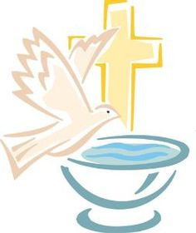
BAPTISMS / SERVICE OF THANKSGIVING
Casey Elford, son of Mike & Amanda (Quipp)
Brother of Vyncent
March 17, 2019

NEW MEMBERS
We welcome to the First Church Family…
Marisa Tippett
during Divine Service – Sunday February 3, 2019

First With The News
Spring Summer Edition 2019

519-631-7570
www.1stunitedchurch.ca
office@1stunitedchurch.ca

