UPCOMING DATES & EVENTS

NOVEMBER
Friday 24th – *Spaghetti Dinner (pg. 5)
Sunday 26th – *RETURN DATE for Secret Santa / Socks /
Food Items for Christmas Care / Grace Café (pg. 6)
*Hug in a Mug Assembly following worship- Fellowship Room

DECEMBER
Sunday 3rd *ADVENT 1 - Tree Trimming – Worship @9:30am
*Holiday Market from 10:30am to noon (pgs. 13 & 14)
*Festival of Lessons & Carols at 7:30pm (pg. 15)

Sunday 10th – *ADVENT 2: Worship @ 9:30am
*Pageant costumes available (pg. 19)
*Holiday Market from 10:30am to noon (pgs. 13 & 14)

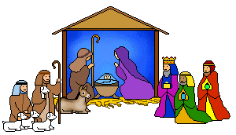
Sunday 17th – *ADVENT 3: Worship @ 9:30am
*Pageant costumes available (pg. 19)

Sunday 24th –*ADVENT 4: Worship @ 9:30am
*CHRISTMAS EVE: Evening Worship @ 7:30pm (pg. 19)
will include the Children’s Bethlehem Pageant!
(Costumes will be available Christmas Eve for those who don’t already have them)

JANUARY
Tuesday 9th - *Last Day for Donations to be credited to your
2023 tax receipt (pg. 21)
From Rev. Paul’s Desk …
One of my favourite holiday movies is White Christmas. I have fond memories of Sue and I getting the kids together each Christmas, all cuddled up on the couch with popcorn on our laps while singing, “I’m dreaming of a White Christmas…”
Watching the movie together was an easier “sell” for our daughter than our sons, but after the obligatory protests, even they settled in and enjoyed the experience. I wouldn’t be surprised if they don’t do something similar when they have their children.
Perhaps my favourite scene is when neither Bob nor Betty can fall sleep and they wander into the lounge of the majestic lodge. A warm fire is burning in the stone hearth, milk and sandwiches sit on the bar counter, a grand piano occupies the centre of the room and Bob moves to it as he offers this advice with his melodious voice, “When you’re worried and you can’t sleep just count your blessings instead of sheep and you’ll fall asleep counting your blessings!”
For many of us, Christmas is a time when we find it easy to count our blessings. This year many of us will feel blessed to gather with family and friends in ways we couldn’t a couple of years ago. Some of us are excited that neighbours have invited us over for some Christmas cheer. And many of us are anticipating attending our Christmas Care/Secret Santa service on Nov 26th, Festival of Lessons & Carols at First on Dec. 3rd & our Advent and Christmas Eve services.
However, before I was blessed with my own family, there was a time when Christmas was a painful time for me, with sad memories of unpleasant Christmases when I was a child. Just as Christmas can heighten our awareness of our blessings, for many, it heightens feelings of loneliness and anxiety.
It will be hard to count your blessings when you know the holiday season will come with the heart-aching awareness of the empty chair at the table. It will be difficult to count your blessings when you are uncertain about whether you have enough money to get through the extra expenses of the season. It will be a struggle to count your blessings when you wake up feeling sad before your day has even begun.
Gathering as Christians is about the only place where we can receive the comfort and joy inherent in the Christmas stories. That’s why we decided to do a nativity scene on the First & Central float in the Santa Claus Parade this year. Last year there was no other representation of the “Christmas” stories.
Few people know that the Christmas stories are about providing love to people in the ways they desperately need it….an inn keeper providing shelter to a homeless couple with child…good news of liberation from violence and poverty proclaimed to shepherds…wise people of another religion travelling to protect the Holy family from Herod’s reign of terror by giving them the means to flee to Egypt as refugees.
Similar challenges are in the news every day, these many years later… refugees fleeing violence…homelessness…growing inequality. And yet, with all these problems, the world has come a long way since 2000 years ago. God was with our ancestors and God is with us, helping us to be a part of God’s salvation.
I’m proud of the way the people at First rally to be a Christmas people, partnering to bring refugees to Canada to reunite a family, partnering with Christmas Care to provide families with gifts and food as well as financially supporting Grace Cafe, St. Thomas-Elgin Food Bank & The Inn (Out of the Cold).
I’m excited about our new pastoral care team and thankful for the volunteers who will provide a “Hug in a Mug” to our seniors. Because of the desire I experience from First to be a community of kindness and a place of support and inspiration, I am looking forward to the journey of deepening and broadening of our community that Spirit is leading us on.
So, as we enter these days of preparing for the Christmas season, may we open our hearts to be a blessing to others while we open our hearts to receive the blessings that God has in store for us.
Most of these blessings won’t come wrapped in packages with tinsel and bows. But as we open our hearts of love and attune our spirits to the gifts that God is providing, we will become even more aware of the blessings in our lives as well as the blessings we will provide for others to count as well.

Happy Advent and Merry Christmas
Paul Browning
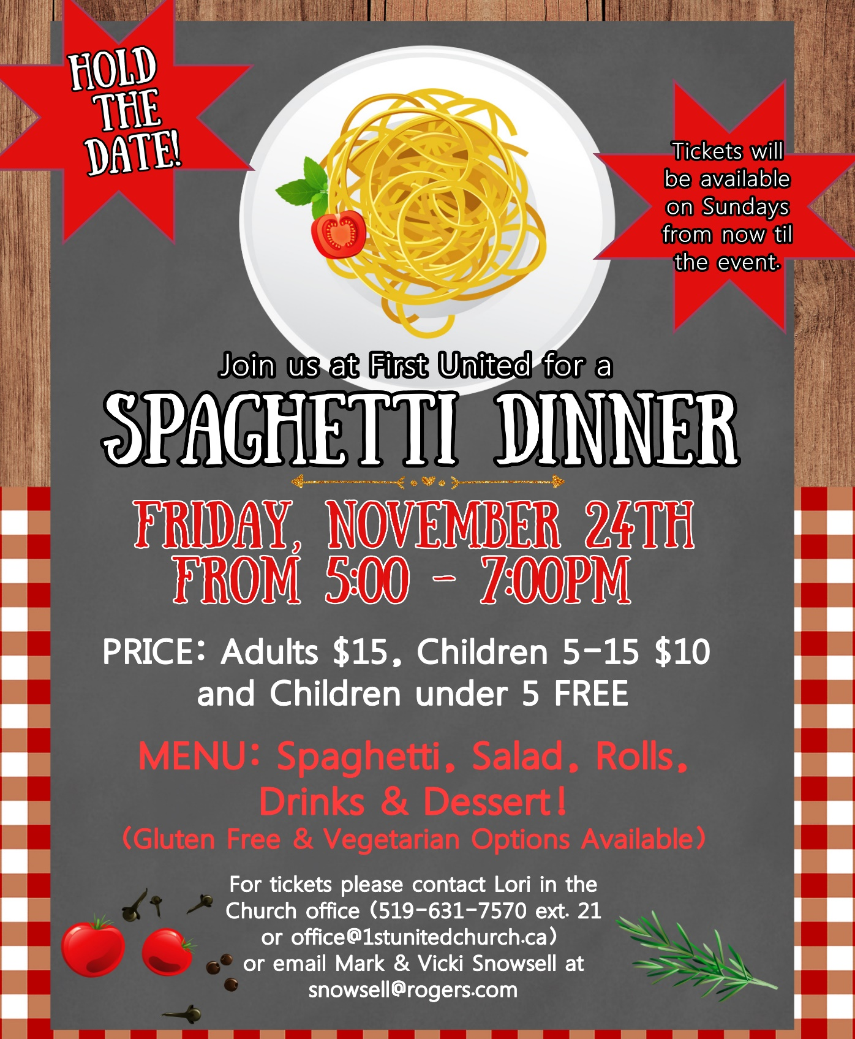

SECRET SANTA & SOCKS PROJECT
RETURN DATE: Sunday, November 26th
OUR GIFTS WILL GO TO CHRISTMAS CARE and from there they will be distributed along with FOOD HAMPERS. If you would like to contribute to the FOOD HAMPERS, please bring non-perishable food items Sun., Nov. 26th
Christmas Care will pick them up the next day!

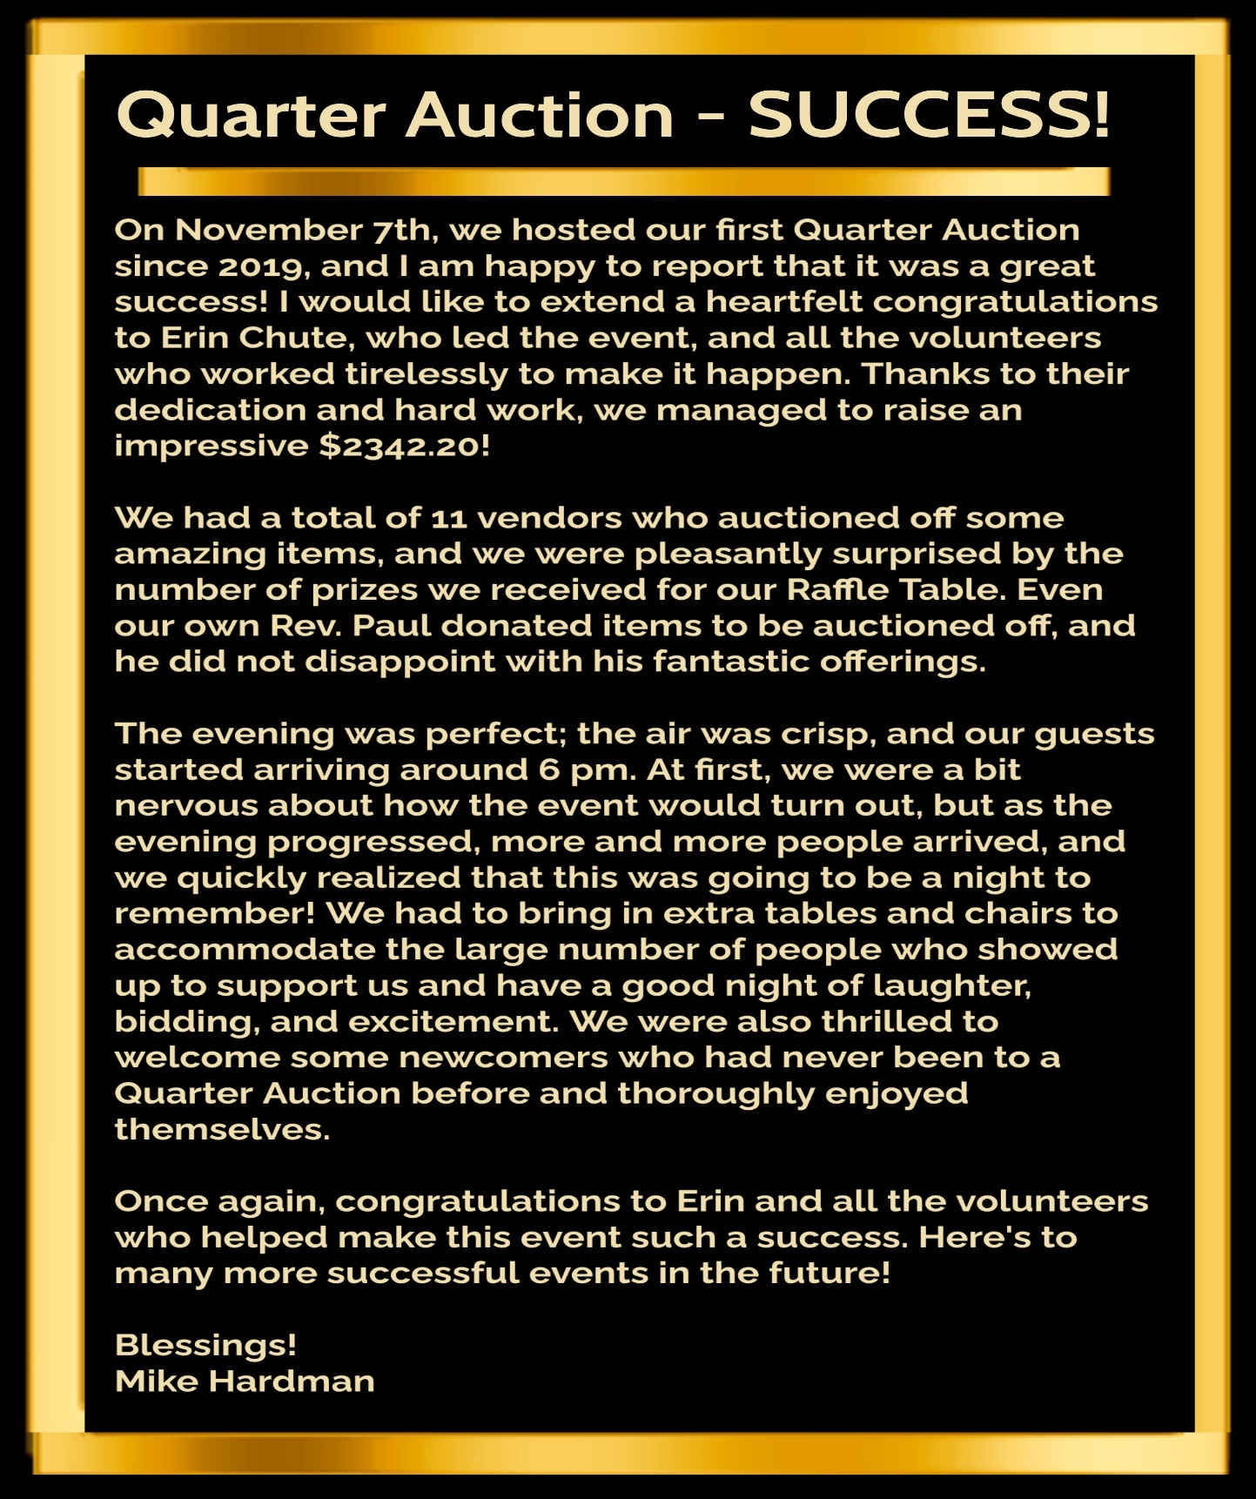

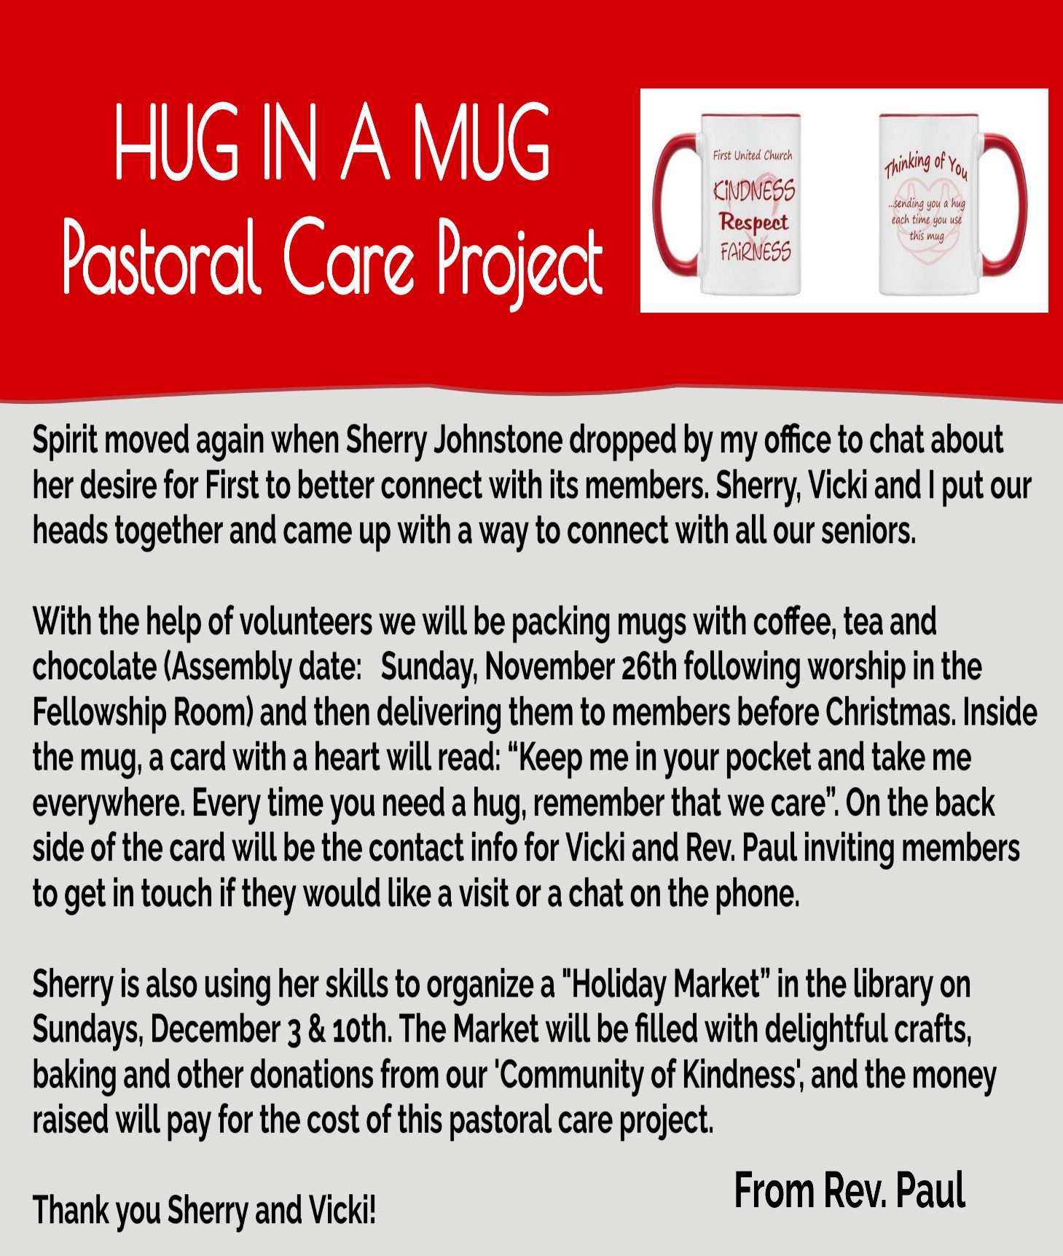
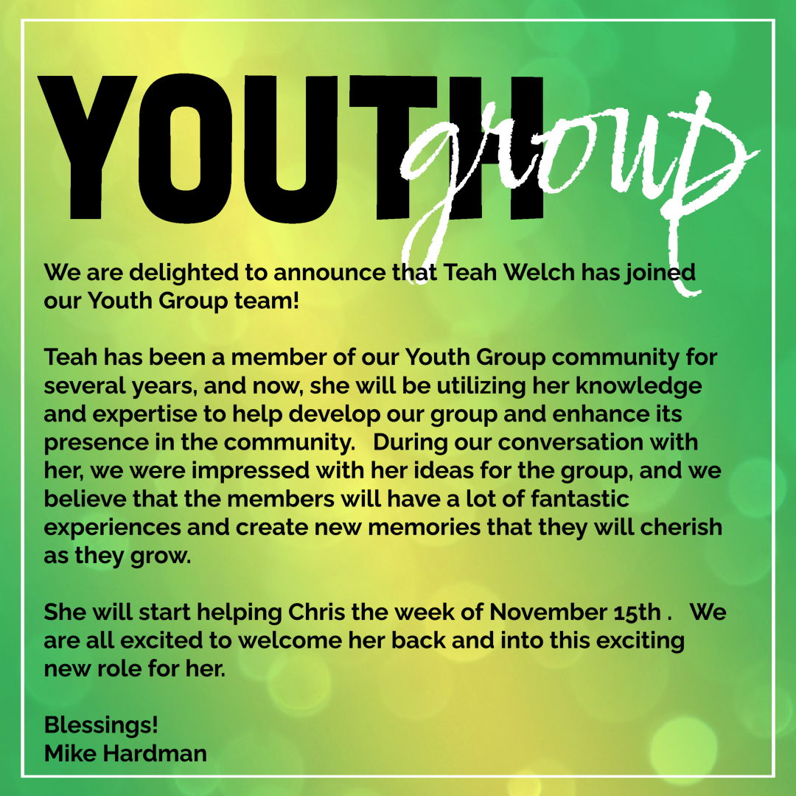
Youth Group meets Wednesday evenings from 7-8:15pm in the Gym at First. For Youth in Grades 6-12! All welcome. Leaders: Chris Ross & Teah Welch

ADVENT & CHRISTMAS
SERVICES AT FIRST UNITED

Sunday, December 3: Advent 1 – HOPE
Tree Trimming Celebration during Worship at 9:30am
Holiday Market: 10:30am to noon.
Festival of Lessons & Carols: 7:30pm

Sunday, December 10: Advent 2 – PEACE
Worship at 9:30am

Sunday, December 17: Advent 3 – JOY
Worship at 9:30am

Sunday, December 24: Advent 4 – LOVE
Worship at 9:30am

Sunday, December 24 – Christmas Eve
with Children’s Pageant
Worship @ 7:30pm

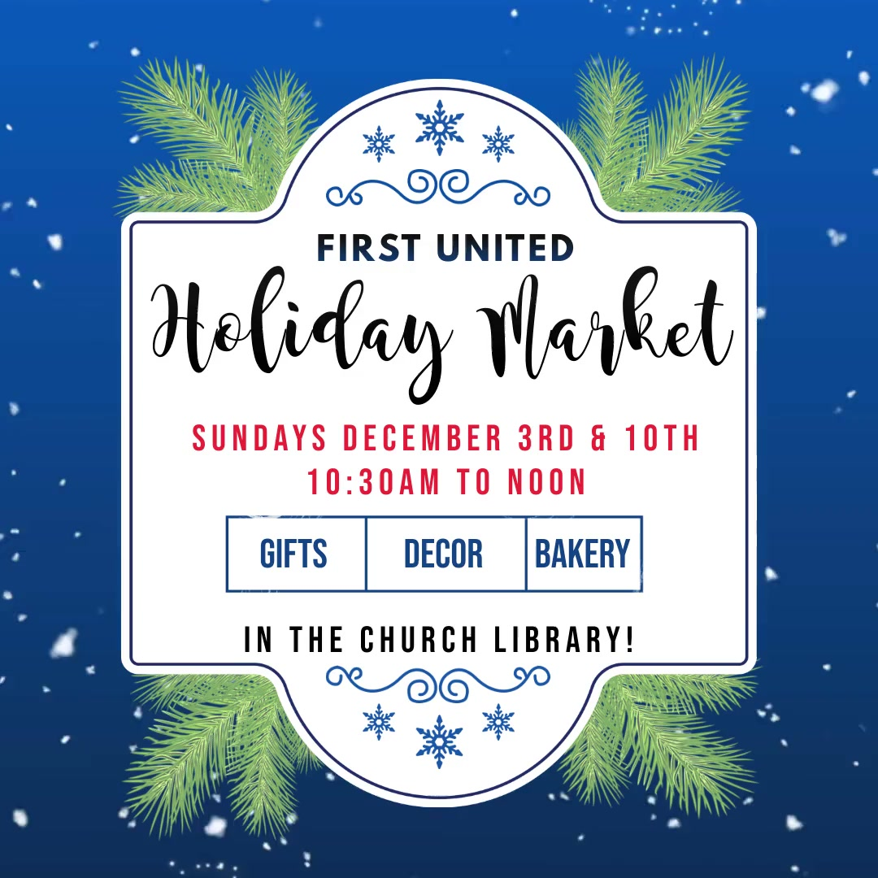

Continued…
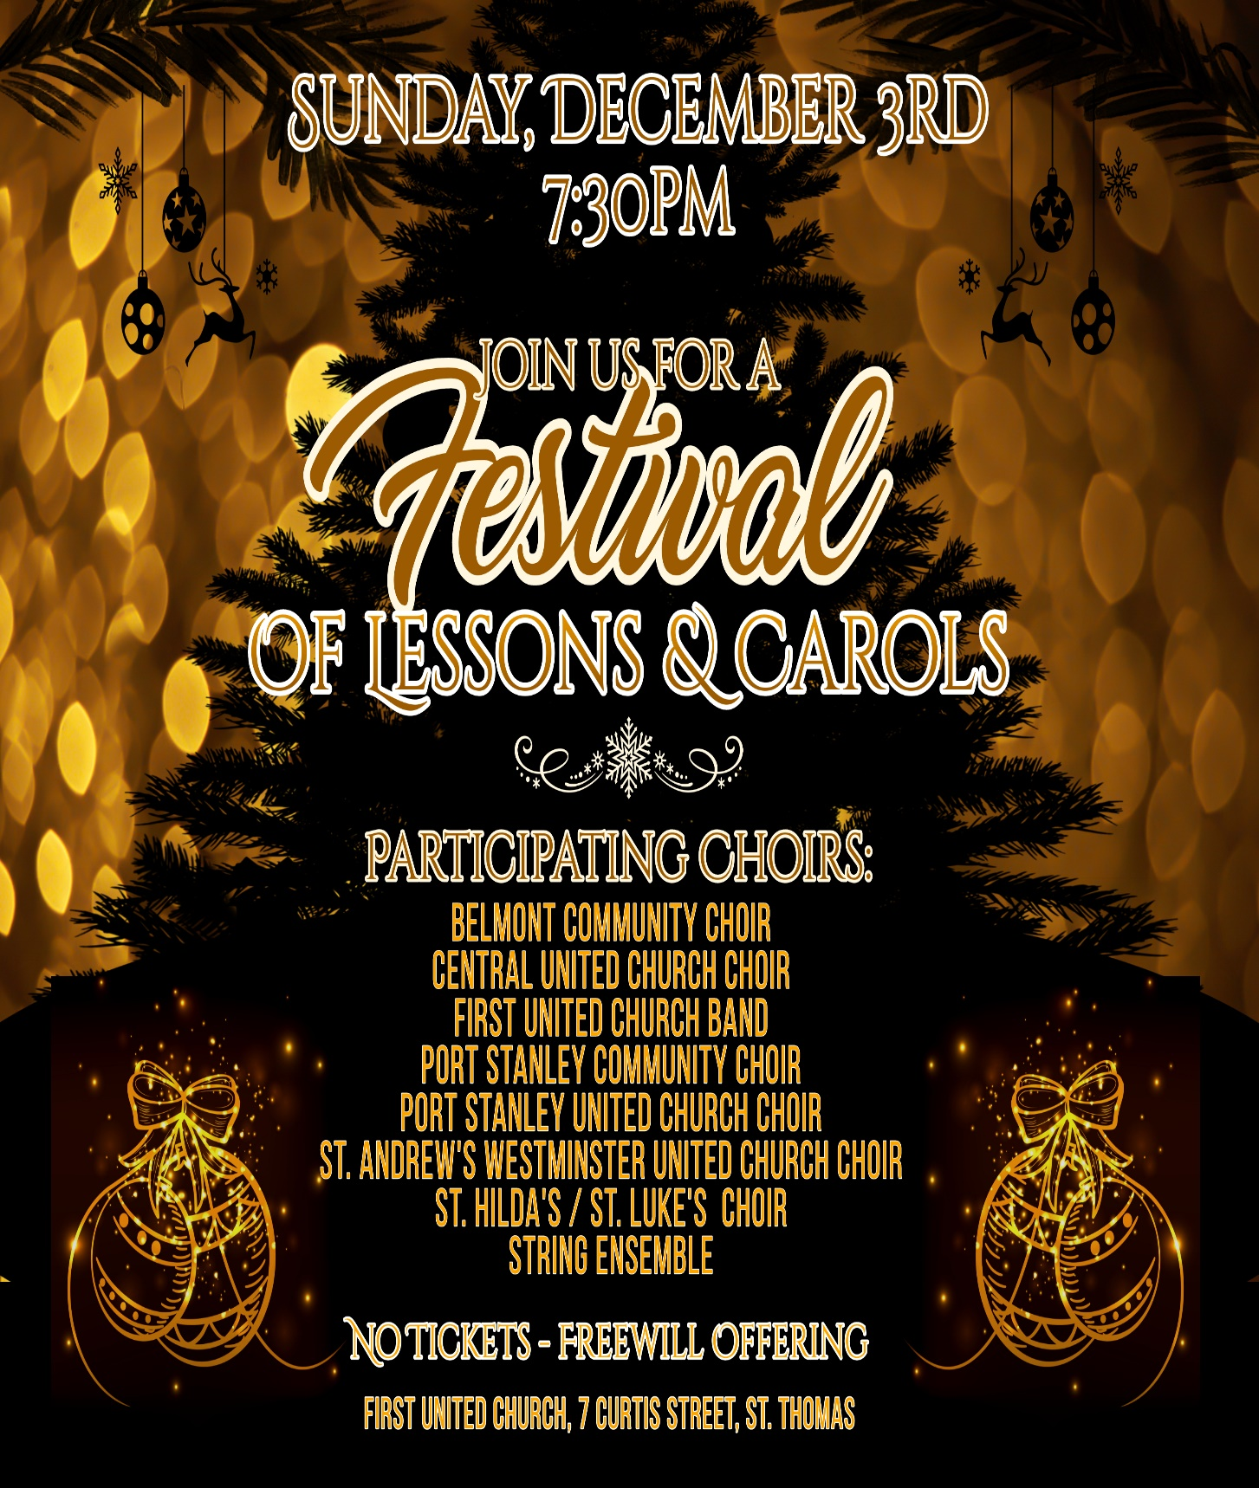

Refugee Sponsorship Update - November 2023
I am happy to provide an update on the work completed to date and information about the Refugee families that First United Church is supporting.

Their Story:
Yousef Alahmad Alzayad and his wife, Iman Mohammad are the parents of 9 children and are from Syria. They fled Syria in October, 2012 after 1.5 years of war. They could no longer stay in Syria due to the high risk to their personal safety and the worsening situation (bombing and killing of innocent people). Several family members in August of 2012 were walking to their grandparents’ home when an airplane launched a bomb, killing a family member (nephew), seriously wounding another family member and one of Yousef’s oldest sons ‘s was injured with shrapnel (left eye and ear) resulting in a three-month hospitalization. Additionally, their older sons were now at the age where they would be drafted to the Syrian army. It was these circumstances that made the family decide to flee Syria. As the Jordanian border was 3 km from their home, they fled on foot along with many people in their village, leaving their home and their belongings. It took them approximately 2 hours to arrive to the border where they received assistance from Jordanian soldiers, received medical attention and were moved to a refugee camp. Iman was five months pregnant with twins when they fled their country.
Yousef and his family lived in a Jordanian refugee camp for ~ 7 months and where their twins were born. Through assistance from the United Nations (UN), they received food and shelter (tents) during the time in the refugee camp. Yousef and his family subsequently moved to the interior of Jordan and he worked washing cars and assisted with accounting (tax filing etc.). Fortunately, in late December 2015 they were
contacted by the UN offering them the opportunity to move to Canada.
Yousef, Iman and 6 of their children arrived in Canada on December 30, 2015. The three remaining children were >21 years old therefore did not meet the refugee eligibility criteria and had to remain in Jordan. Yousef and his family have tried for years to find a group that would support the sponsorship of his three grown children and their families as he is ineligible to sponsor his family per the Government immigration criteria.

Continued…

Our Sponsorship:
The United Church of Canada (UCC) have agreements in place with Immigration Canada and can provide private sponsorships. However, there is an annual quota resulting in at least a one year wait BEFORE the UCC submits the application to Immigration Canada. On behalf of the UCC, First United Church works with the refugee families, ensures completion and submission of all the required documentation and acts a liaison between UCC and the refugee families.
Our sponsorship will support Yousef’s three adult children and their families to move to Canada reuniting this family.
Our application is for a total of 15 people (3 families of 5). The families are currently living in Jordan. Yousef and Iman are responsible for providing $31,000 per family (a total of $93,000) to First United Church. These amounts are established by UCC. These funds will be held in trust and then used to support the families when they arrive in Canada for the first 12 months. Yousef has raised $80,000 to date and has transferred it to our Church. The remaining funds will be required within a year.
In addition to raising the funds for the settlement costs, Yousef and Iman also send money regularly to Jordan to assist in supporting their children and grandchildren. They shared that everyone in their household (even their 10-year-old twins) work multiple jobs and even the children are required to give 50% of any money they earn from babysitting, grass cutting etc. towards bringing their family members from Jordan.
Yousef and Iman are well established in London and have a great deal of support through the Mosque and are part of a large Syrian community. In addition to providing the funds for settlement they will provide a great deal of support and assistance with their grown children and families.

Where are we in the process?
I am pleased to share that we have completed all the required forms and applications and formally submitted to UCC! We have a formal memorandum of understanding (MOU) in place with Yousef outlining roles and responsibilities related to settlement and funds. We are now on the UCC wait list where we will likely wait at least a year before the UCC will formally submit the paperwork to Immigration Canada. Recent media stories have highlighted the delays in the government process; therefore, we anticipate at least a 20 month wait BEFORE Immigration Canada begins to review the application. Once approved by Immigration Canada we will be notified and the families typically arrive within 10-20 days. Continued…

Final thought:
I have had the privilege to get to know this family. They are generous and kind people and have taught Bill and I so much already about their faith and community. We have always known that we are fortunate to live in Canada and enjoy many freedoms, however as we listen and learn from Yousef and his family and the horrors they have been through (including being separated for years from their children and grandchildren), our appreciation for our Country and gratitude has deepened and we are very motivated to help this family be reunited.
Respectfully submitted,
Heather Tales
Heathertales108@gmail.com

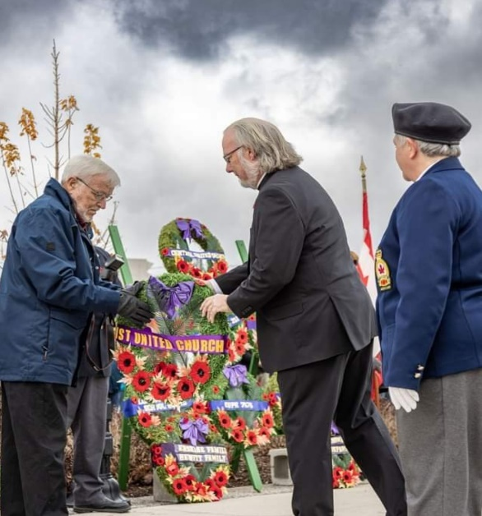
Outreach Program Ideas

Dear Fellow First members,

Hello! I hope you are doing well and enjoying the beautiful Autumn season in Ontario in all its glory. The crisp air and vibrant colors of the trees make this season truly special. As the Advent season quickly approaches, I wanted to reach out and ask for your help in identifying some outreach programs that we can participate in as a community.

I have been giving this some thought for a while now, and I believe that the time to take action is now. If you have any ideas or suggestions, please do not hesitate to contact me at mhardman766@gmail.com. Your input would be highly appreciated.
Thank you for your time and consideration.

Blessings!

Mike Hardman
Rev. Paul laying the First United Church wreath at St. Thomas’ Remembrance Day Service, November 11, 2023.
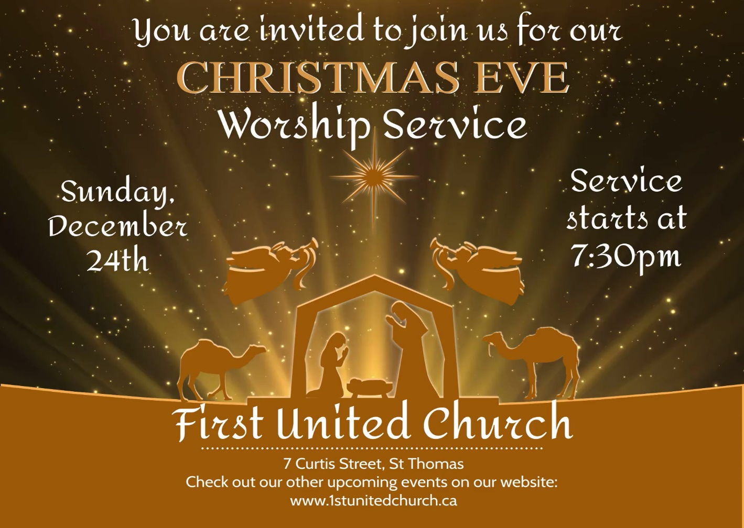
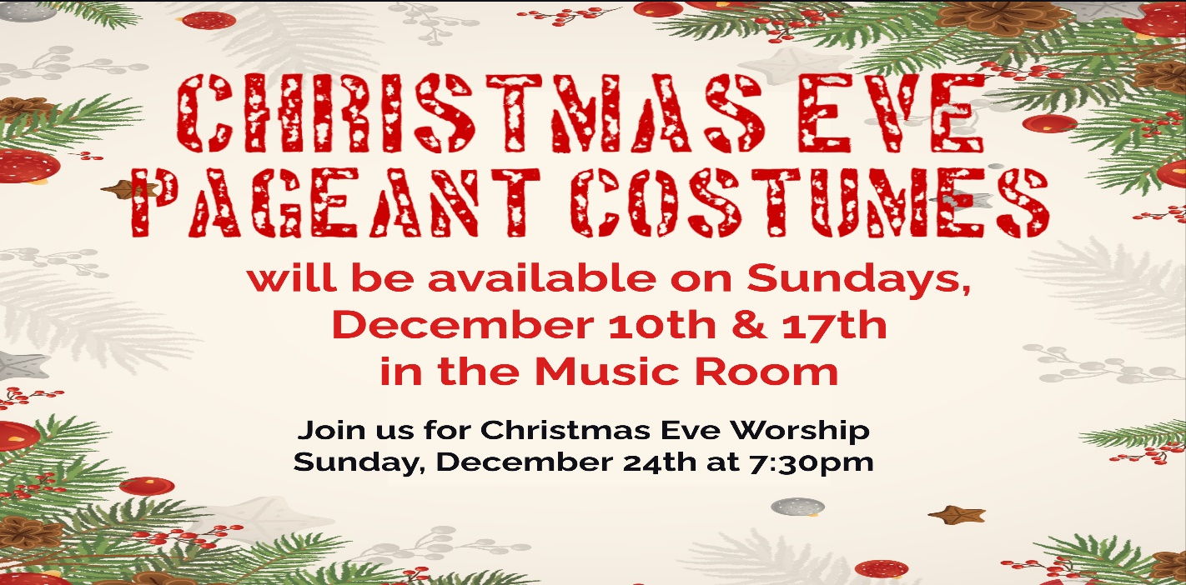
Merry Christmas from your Stewards Team
(Formerly the Finance & Property Committees)

We’re sorry we can’t bring you better news for this festive season, but we are still losing money. Our operating loss on Oct 31st amounted to almost $60,000. On average our revenue/donations are short about $6000 per month. The good news is that our investments remain strong enough to sustain our church into next year. The Board continues to investigate alternate uses of our building to create additional revenue streams, but this will take some time.
So, what do we do in the interim? Although this is a joyous time of the year celebrating the birth of Jesus, we do realize that for many, Christmas puts a strain on family finances. However, we do need financial help. So, for those who are financially able, we ask that you put on your virtual Santa Hats and send a Christmas gift to your beautiful church. Additional donations of any amount would be helpful and very much appreciated. Hopefully, with your continued support and all our prayers we will continue on a path to revitalize our church and guarantee it has a long and thriving future.
Scan the QR code to make a donation

Thank you,
Your Stewards Team: Justin Chute, Mike Hardman,
Lori Hoffman, Don Renaud & Bill Turvey

More from your Stewards Team ….
Have you ever considered going on PAR (Pre-Authorized Remittance) or donating online through Paypal?

PAR is a once-a-month withdrawal from your bank account (around the 20th) to help support the ongoing ministry of First Church. Paypal is a secure online payment service that gives you the flexibility to donate using your credit or debit card.. and there’s a link on our website (http://1stunitedchurch.ca/ways-to-donate.html) or you can scan the QR code above and it will take you to our Paypal website)!

Why are we promoting these services?
Both of these options are quick, easy and they save the church money!
With PAR & Paypal there’s no waste and no worries! The money is automatically deducted from your account, credited to the church and you still receive your tax receipt at year end. Both services do NOT charge you for using their systems, so there is no cost to you personally. SO SIMPLE, SO COST EFFECTIVE!

If you would like to sign up for PAR (we need a form filled out - available in the church office or on our website - & a void cheque) or would like more information on either of these options, give Lori a call in the Office (519-631-7570 ext. 21) or send her an email (office@1stunitedchurch.ca).

Please remember, by signing up for any of these alternate methods of donating, you are saving our church money and contributing toward the maintenance of our Church into the future.
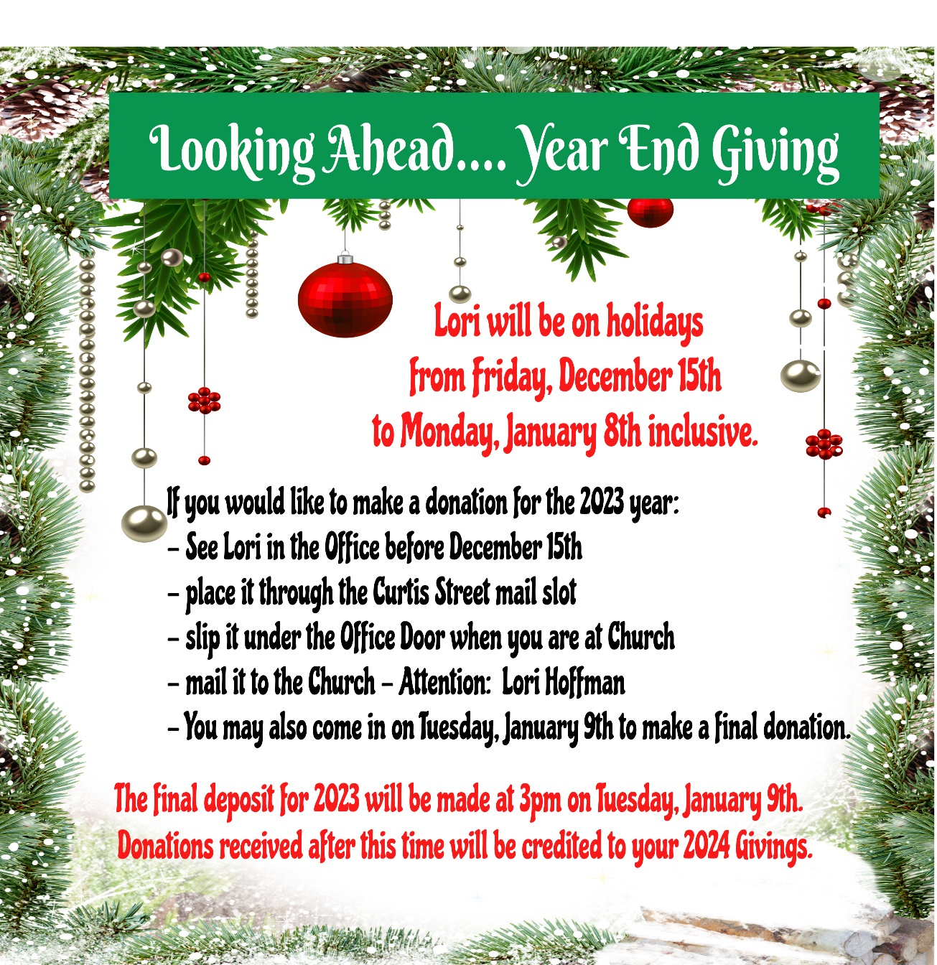

Committee Updates
Membership
We want to thank those who have offered to help with juice, coffee and/or treats after the services on Sundays. It is appreciated! If anyone would like to help out, there is a sign-up sheet on the table in the Fellowship Room.

We are also looking for ideas from the congregation about how they’d like to connect with one another. Games night? Movie night? Paint night? Concert? External event at a restaurant? Let us know! We want to do some fun things with you and want to know what you consider fun!

We hope you have a blessed Christmas season.

Submitted by Debbie Alward, Erin Chute, Carol Gagen

Property – Concrete Work
A new sidewalk is being installed on the south side of the church from the stairway to the Curtis Street sidewalk.

The work is being completed the weeks of Nov. 6 and 13, and cars need to stay off it for 2 to 3 weeks.

You can walk on it this coming weekend.

Pylons are placed in front of the pour to restrict vehicle movement.

Submitted by Richard Auckland
Trustees
As trustees it is our role to look after property matters. It is so nice to see our Education Wing being used for Education. We are committed to working with King’s Academy for these next two years at which time we will review our arrangement.

We have had to sell some of our investments in order to pay back $40 000 to the federal government for the $60 000 loan we received during COVID ($20 000 is being forgiven as we are paying back the loan prior to December 31, 2023).

We continue to work with our lawyers and insurance companies over two lawsuits that have been brought against the church.

Submitted by Richard Auckland

Regional Council
The work on regional council is rewarding. I have learned so much during my 5 years with Antler River Watershed. For the last 4 years I have served as chair of the Discipleship & Justice Commission which promotes social justice issues like Truth & Reconciliation with our Indigenous neighbours like the Remit that the United Church has raised to give the Indigenous Church some autonomy within the United Church of Canada. Additionally, our group reviews and awards Mission Support Grants within our geographic area. Your Mission & Service dollars do stay local to help out camps like Pearce Williams, the London Community Chaplaincy which serves the underprivileged in the area, and chaplaincies on area campuses like Ridgetown. If you’d like to become involved please see me.

Submitted by Richard Auckland
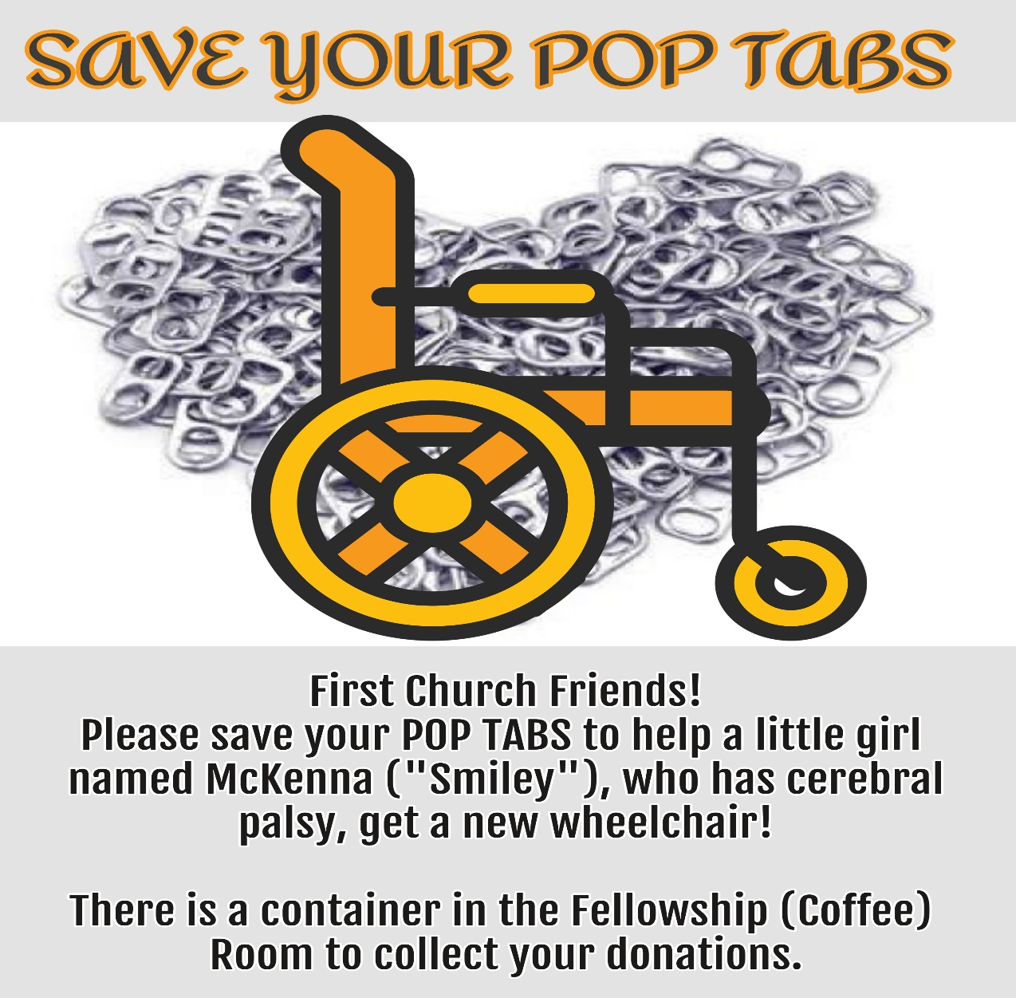
First With the News – November 2023
If you don’t receive our Weekly Update emails (on Thursdays) and you’d like to start, email Lori in the Church office: office@1stunitedchurch.ca

If you no longer wish to receive Newsletters from First United Church,
please send an email to office@1stunitedchurch.ca or call 519-631-7570 x21
and leave a message.

