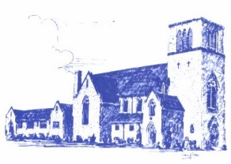
First United Church
7 Curtis Street, St. Thomas, Ontario N5P 1H3
Phone: 519-631-7570 Fax: 519-631-2052
Email: office@1stunitedchurch.ca
Web: www.1stunitedchurch.ca

Intentional Interim Minister: Rev. Daryl Webber
Ministers: All the People

September 2, 2021

Happy September First Church Friends!

Our Worship & Christian Education groups from Central and First have been working together over the summer months to create a meaningful and nurturing worship for the whole family. In fact, the work began last January with the Worship Dream Team! So, it has been a long time in the making, with many people behind it, both at Central and First! We hope to make a strong new beginning with our First Family on Sunday, September 12, Rally Sunday.

Since traditionally First has gone to Pearce Williams to get things wound up for a new start to the church year, the Committee thought it would be good to retain a camping theme. So, on Sunday, September 12 (10:30am) come out for some stories, a campfire, crafts and a good time over Ice Cream Sundaes afterwards! We look forward to this time together to worship the Lord. So come in person, or online if you are more comfortable with that. Central will be celebrating in a similar manner, and we will share live components of our worship services. Come see our experimental worship model! By the way, the First Board is pretty sure we can eat more ice-cream than our Central kin!

Since we are paring down the service and will no longer be formally receiving an offering on Sundays (although an offering box will be available for donations) Rally Day Sunday will provide an opportunity to sign up for PAR. Pre-authorized Remittance has been around for 20 years and many churches including Central have strong support through PAR. First has a very low number of people on PAR. We’d like to see that shift. You can sign up for a monthly donation of any amount and it automatically goes to help your church and its mission.

Come to Rally Day Sunday (see back) for a re-opening of church, to celebrate being together (socially distanced, masked and no singing to be safe) and together we will see what is old and new in our Sunday Morning gatherings. Stay tuned to your weekly email for updates!

Blessings
First Board and Rev. Daryl

at First United Church
Sunday, September 12th at 10:30am

We invite you to return to church!!
(safely, with social distancing, masks
and no singing… yet! )

We have been busy this summer planning for our return to church! Rally Sunday will have a Camping Theme!
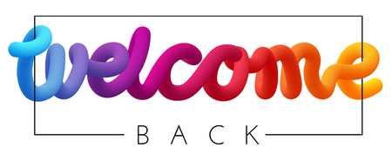

Join us for stories, a campfire, crafts & a good time over Ice Cream Sundaes following worship!
You are welcome to join us in person or online!

