First With the News
Seeking to be a welcoming community of Christian faith,
proclaiming and celebrating the love of God in Jesus Christ
through the Inspiration of the Holy Spirit.

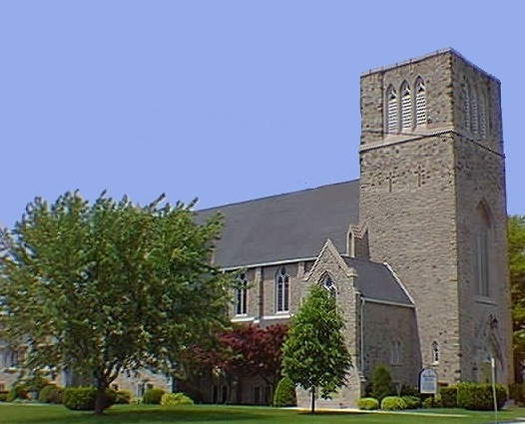

Spring/Summer 2018 Edition

Delivered by: ______________________________________________________

UPCOMING DATES & *SERVICES

MARCH
Thurs. 29th – *MAUNDY THURSDAY COMMUNION SERVICE @ 7pm

Fri. 30th - *GOOD FRIDAY WORSHIP @ 10:30am

APRIL
Sun. 1st – *EASTER SUNDAY WORSHIP @ 10:30am
Communion will be served.

Sat. 21st - *First United Church “RETREAT” 9:00am to 2:00pm (pg 7)

Sat. 28th - *SPRING RUMMAGE SALE from 8:30-11:30am in the Gym (pg 8)

MAY
Sun.6th – *SPRING VISITATION (pg 8)

Sun. 13th – *MOTHER’S DAY / FAMILY SUNDAY – Worship @ 10:30am

JUNE
Fri. 1st - *JACOB MOON CONCERT @ 7:00pm at First. (pg.9)

Sun. 17th - *FATHER’S DAY / FAMILY SUNDAY – Worship @ 10:30am

SEPTEMBER
Sun. 9th – *RALLY DAY– Worship @ 10:30am

Sun. 16th – *CHURCH SCHOOL REGISTRATION

*Sunday worship times are 10:30am throughout the year

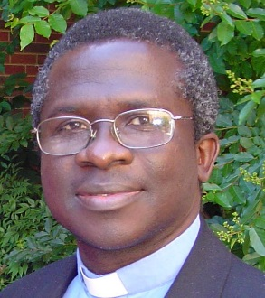
From the Pastor’s Desk …
… OF CELEBRATIONS AND GOOD FRIDAY & EASTER
The month of March is very important to me and the people of Ghana.
On March 6, 1957, Ghana won its independence from British rule and
became a republic on July 1, 1960. Ghana celebrated its 61st Independence
Anniversary a couple of days ago as the people reflected on God’s blessings and the relative peace being enjoyed. They also paid tribute to the gallant men and women who shed their innocent blood for freedom from colonialism.
Secondly, March 25 will bring into memory another anniversary – The Abolition of the Slave Trade Act of March 25, 1807 which outlawed the Slave Trade leading to the demise of the transatlantic triangular traffic in human beings. The global Slave Trade removed most of the finest and productive peoples in Africa, resulting in what is described today as the “African holocaust”. They were carried off from the coasts of Africa into the Caribbean islands and Americas. Some of these able-bodied men and women were brutally captured and kidnapped as slaves; stolen, sold and resold.
They were tortured, raped and treated like cargo. Others were thrown into the Atlantic Ocean when found to be weak, sick or at the verge of dying. These noble Black men and women worked on the sugar and other plantations; their sweat sugared the tea and buttered the bread at the breakfast table in all European and North American homes during that period. Their shoulders, in part, spinned and oiled the industries that catapulted Europe into economic boom. All these went on during the industrial revolution and the so-called Enlightenment era!
On the bright side, good people of conscience rose up against this injustice and crime against humanity. They included evangelical Christians like John Wesley (founder of Methodism) and John Newton (former slave merchant and a Christian convert who later wrote the hymn Amazing Grace), politicians like William Wilberforce and countless ordinary British citizens like Hannah More (the most influential female member of the Society for Effecting the Abolition of the African Slave Trade) who signed petitions, marched, lobbied and prayed for change. I doff my hat to slaves and former slaves like Olaudah Equiano who used his God-given skills to work his circumstances into a means of liberty and later fought for the freedom of his own race.
The United Kingdom observed the bicentennial anniversary of the abolition of the Slave Trade in 2007 under the theme: “Reflecting on the Past, Looking to the Future”. However, it is sad to note that the effects of slavery remain today in terms of racism, economic exploitation and psychological damage to the millions of Africans and their descendants. Modern forms of slavery include human trafficking, child labor, sex trade, and institutional racism.
As I reflect on Ghana’s Independence and abolition of slavery, another form of slavery which Jesus spoke about comes to mind: “I tell you the truth,” He said, “everyone who sins is a slave to sin” (John 8:34). Sin enslaves because every act of disobedience to God creates an atmosphere of alienation and a trend to further disobedience that inevitably makes escape impossible. We all need freedom from these bondages, including other forms of addictions that might not be classified as “sin” per se.
The good news is that on one Friday, about two thousand years ago, Jesus was fastened to a rugged cross; on that GOOD FRIDAY, He purchased eternal freedom for all of humanity – freedom from spiritual slavery and its effects; from the power and guilt of sin. His death is good in the sense that it has given us forgiveness of sin and sealed our freedom.
In a couple of weeks – Friday, March 30, 2018 – it will be remembrance of GOOD FRIDAY, and we will be celebrating the profundity of the “abolition” of slavery to sin. As Ghana celebrates its 61st Independence Day, and Great Britain, Canada and others celebrate the 211th anniversary of the abolition of the transatlantic Slave Trade, Christians globally celebrate the death and resurrection of Jesus Christ to free humanity from the power and guilt of sin.
Celebration of GOOD FRIDAY and EASTER could be a profound experience for you if you would decide to avail yourself to and appropriate the freedom Jesus gives to all who come to Him in faith. Remember, Jesus spells freedom – Christ has power to set you free from sin, from all forces of negation and every form of slavery, including addiction to sex, food, drugs, tobacco, anger, envy, drunkenness, and other destructive habits. He then gives joy, peace and love your heart longs for. This is yours for the taking; simply stretch forth your hand, receive it by faith and it shall be yours today.
Hannah and our children, Samuel, Emmanuella, Grace and Stephen, join me to wish you happy GOOD FRIDAY and EASTER celebrations. May these celebrations help you seek and see the freedom in Christ for your life. May you know life in Christ and enjoy it abundantly.

Keep the faith, and spread it gently.
I am your pastor and friend,
Rev. Emmanuel K. Ofori
Notes from Jody
What is it in human life that cannot do without a song?
What is it in our Church tradition that cannot do without a hymn or a chorus?
The answer lies close to the heart of our identity. We sing out of who we have become as people and spiritual beings, yet that singing can take on new forms as our identity and sense of belonging expand over time. We sing what we belong to and feel at home in. But we also sing in order to become part of a larger social reality. What some call spirituality- a way of being fully alive-is shaped by both of these pulls. The Senior Choir, Children's Choir, soloists, instrumentalists, Jerome and congregation all represent this Church tradition that is a reality here at First. We worship together in song every Sunday bringing us together to sing our faith! Thank you for being a part of this with me and sharing your time and gifts.
Musically yours,
Jody

From the Church Office
Here at First we love to celebrate birthdays and anniversaries during our “Life & Work of the Church” time in the Sunday service. We are able to celebrate those dates because you have called them into the office. Please give me a call so I can record your dates too! If you have recently moved or are new to the Church – let me know that too. Thank you for helping me keep all our information up to date (eg addresses, phone numbers, birthdays, email, etc.).
We are also trying to do our part to cut down on our paper usage AND save money in postage fees! We are attempting to send out all of our mailings electronically! There are sometimes a couple of emails a week to keep the congregation updated (or reminded) on what’s happening at the Church! If you would like to receive mailings electronically, please send an email to firstunited@bellnet.ca to let me know and you’ll be added to the list! It's that easy!
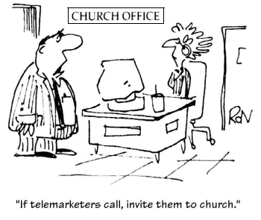
If you need offering envelopes or would like to go on PAR (pre-Authorized Remittance) – I can help you with that! We also have online giving by credit card or through your bank account through Paypal on our website (http://firstunitedchurch.weebly.com/ways-to-donate.html).
If you would like more information about the Church or its
“Happenings” or just have questions, call me at 519-631-7570,
email me at firstunited@bellnet.ca or check out our website at www.firstunitedchurch.weebly.com
Lori
Covenanting Service
On Sunday, March 18th, Rev. Emmanuel K. Ofori’s Covenanting Service was held at First United Church. The service was presided over by Rev. Dr. Donna Kerrigan, Chair of Elgin Presbytery. Special greetings were given by representatives of Elgin Presbytery and London Conference and many United Church of Canada Representatives were in attendance.

The Guest Preacher for the afternoon was Rev. Don Gibson from Runnymede United Church, Toronto. Rev. Gibson was Rev. Ofori’s mentor and supervisor when he first became a minister with the United Church of Canada. Rev. Gibson read scripture: Mark 1:29-39 and then gave his Reflection, “In a Hurry”. He spoke of how people hurry through the Journey of Faith and that we should instead trust in God and have faith that good things will come in their own time.

Following the Reflection, Rev. Ofori was presented with “Symbols of Our Ministry” by members of First United: a Bible; a beautiful Candle to symbolize Christ’s Light in the world; Water to symbolize the water used to celebrate the Sacrament of Baptism; Wine & Bread to symbolize the Holy Elements of Communion; a Bell cast from the original First United Church Bell that hung in the tower of the previous church; and a brass “Jumbo” to represent St. Thomas and to symbolize our welcome to Rev. Ofori and his family to our Church and wider community. Rev. Ofori responded with many thanks to all in attendance for their love and support of his ministry at First.

Following worship everyone gathered in the Assembly Hall with Rev. Ofori, his wife Hannah, daughter Emmanuella, and son, Stephen (son, Samuel and daughter, Grace were unable to attend) for a reception to honour Rev. Ofori’s Covenanting.
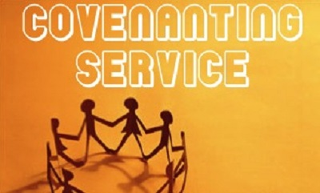
HOLY WEEK WORSHIP

PALM SUNDAY, March 25 - Worship @ 10:30am

MAUNDY THURSDAY COMMUNION SERVICE, March 29 - Worship @ 7pm

GOOD FRIDAY, March 30 - Worship @ 10:30am

EASTER SUNDAY, April 1 - Worship @ 10:30am
Communion will be served.

First United Church ‘Retreat’
Saturday, April 21 from 9am to 2pm

The purpose of this Retreat is:
To Explore the Vision of First United Church
and come up with vision/goal strategies.

The Retreat is open to any congregation members who are interested.

If you would like to come, please sign up with Lori in the church office (there are handouts to pick up as well).

If you would like more information, or clarification about the Retreat, please speak to Rev. Emmanuel.
Spring Rummage Sale
Saturday, April 28 from 8:30 - 11:30am
We need lots of volunteers to make this a successful sale and fundraiser!
**8:30am – Monday, April 23 – Men to set up Assembly Hall & Gym for the Sale. Tables, chairs and racks involved.
**Men, women and young adults needed to help sell merchandise at the Sale on Saturday, April 28 from 8:30 to 11:30am plus clean up help if possible.
**CLEAN UP CREW for Saturday, April 28 11:30am. Pack up remaining merchandise. Tables & Racks taken down and put away.
Donations wanted: *Excellent quality spring ladies clothing requested for our special boutique. All sizes welcome! *Good, clean Spring / Summer clothing for all ages. *General Household goods - Small furniture items, puzzles, linens, bedding, art, kitchen items, etc.

Items can be brought to the Accessibility Door Monday to Thursday 9am to 3pm. Call Lois Whiteman (519-631-3337) for further information.
MEMBERSHIP COMMITTEE SPRING VISITATION
Sunday, May 6
There are wonderful members of this church who are unable to come out to worship. Our hope is to have each one of them receive a spring plant and a visit from First Church. We want them to know in their absence they are not forgotten.
Would you consider delivering a plant to one of these members? Simply come up to the tables under the pulpit after worship, and you will be given a plant, a name and an address. The visits are to bring happiness, joy and greetings from First Church. They do not have to be long … just cheery!
Our hope is that enough people come forward so that each visitor only has one plant to deliver. The Membership Committee

First United Church proudly presents:
Tremendous command of the instrument...amazing voice. I can honestly say that I am overwhelmed by his music. - Danny Miranda (bassist for Queen)

Friday, June 1st @ 7 p.m.
at First United Church

Tickets are $15.00 and are available
in the church office during the week, after worship on Sunday mornings in the Fellowship (Coffee) Room or by calling Esther @ 519-619-5107
or Jody @ 519-495-4819.
Views from the Pews
Mat 8:23 Jesus got into a boat, and his disciples went with him.
Mat 8:24 Suddenly a fierce storm hit the lake, and the boat was in danger of sinking. But Jesus was asleep.
Mat 8:25 The disciples went to him and woke him up. "Save us, Lord!" they said. "We are about to die!"
Mat 8:26 "Why are you so frightened?" Jesus answered. "What little faith you have!" Then he got up and ordered the winds and the waves to stop, and there was a great calm.
Jesus was with the disciples even if He was sleeping. There was no chance of any harm coming to them. Yet they panicked ! Because Jesus is Love, He scolded them slightly. Then removed their fear by calming the storm.

If you’re a born again Christian, then you also have Jesus with you at all times.
Scripture says I am with you always even unto the end of the earth.
If a storm of life hits you, then you have the same right to call upon Jesus. He may rebuke you for your lack of faith, just like the disciples, but He will calm the storm. You only have to believe.
To be born again requires you to confess Jesus as your Lord and Saviour with your mouth. Your pastor or anyone else can’t do it for you. You have to speak it yourself. Why be born again, like Nicodemus asked Jesus. Think about it, when a baby is born it has a present and a future but no past!
So God is saying to you, if you are born again by accepting Jesus as your Lord and Saviour, you have no past as far as He is concerned. God states in scripture your sins I will remember no more.
How do you become born again? By confessing the following prayer.
Lord Jesus I repent of my sins. Come into my heart. I will make you my Lord and Saviour.
If you said this prayer you are born again. It’s the only requirement for salvation according to scripture. But don’t use it just like an insurance policy to get you into heaven. Use it as the beginning of a walk with Jesus. Read the bible and find out what God is saying to you. Eventually you will learn to trust God’s Word at face value. When storms hit and they will, you can call on Jesus to calm them.
God Bless

Submitted by John Surmacz

From the Finance Committee
First Church Friends,
Have you ever considered giving up your offering envelopes
and going on PAR (Pre-Authorized Remittance)... or donating
online through Paypal?

PAR is a once a month withdrawal from your bank account (around the 20th) to help support the ongoing ministry of First Church.
Paypal is a secure online payment service that gives you the flexibility to donate using your credit or debit card.. and there’s a link on our website!
(http://firstunitedchurch.weebly.com/ways-to-donate.html)

Why are we promoting these services?
Both of these options are quick, easy and they save the church money!
There are so many sets of costly envelopes that are wasted. Either they aren’t picked up or, because we don't all get out to church each week, the remaining unused envelopes are thrown out.
With PAR & Paypal there’s no waste and no worries! The money is automatically deducted from your account, credited to the church and you still receive your tax receipt at year end. Both services do NOT charge you for using their systems, so there is no cost to you personally. SO SIMPLE, SO COST EFFECTIVE!

Concerned the people around you will think you’re not giving because you’re not putting anything on the collection plate? We have small inexpensive business-sized cards available for you (on the table in the narthex or on the sound system... or available from the church office) to put on the plate indicating you’ve given in another way. We’ve got all the bases covered!!

If you would like to sign up for PAR (form [attached or available in the church office] & a void cheque) or would like more information on either of these options, give Lori a call in the Office (519-631-7570) or send her an email (firstunited@bellnet.ca).

Please remember, by signing up for any of these alternate methods of donating, you are saving our church money and contributing toward the maintenance of our Church into the future.
From the Membership Committee
We have 2 Requests:
- We are looking for people to help in the Kitchen on Sunday mornings preparing and serving Coffee and Juice (and Green Tea for Rev. Emmanuel) for the fellowship time following worship.
- We are seeking people who might be interested in being on the Membership Committee!

If either of these things are something you’d like to help with, please call Ruth Zions (226-289-3055) or email her at ruthzions@gmail.com.

We would love to have you! Thank you!

Thank you to everyone who helped with the Shrove Tuesday
Pancake Supper. Special thanks to our ‘Core Group” leaders
for all their work! A profit of $701.50 was raised for the
General Fund! Thank you for your support!!
From the Church Library
Kristin Legault-Donkers has a written series of stories dealing with mental health issues geared toward school age children. Kristin, a resident of St. Thomas, has had personal struggles with, and family history of mental illness. These stories deal with depression, anxiety, ADHD and bipolar disorder.
They are titled:
Zack’s Moods Are Like A Roller Coaster
Zack, The Very Busy Kid
Zoey Has Worry Thoughts
Zoey Has Very Glum Days
Thanks to Kerry Barrett for donating these books to out Library!

Rosemary Underhill has donated a book entitled, “Thrive”. The author talks about managing time & prioritizing career demands. “Our eulogies are not about our Resumes – they are about small kindnesses and generous acts.”

Positively Canadian – a fun guide to Canadian language, culture and history – utterly readable & delightfully entertaining.

For the Kids – There are lots of books pertaining to Easter & Spring!

Submitted by Edith Nimmo
Holly Fair Report…
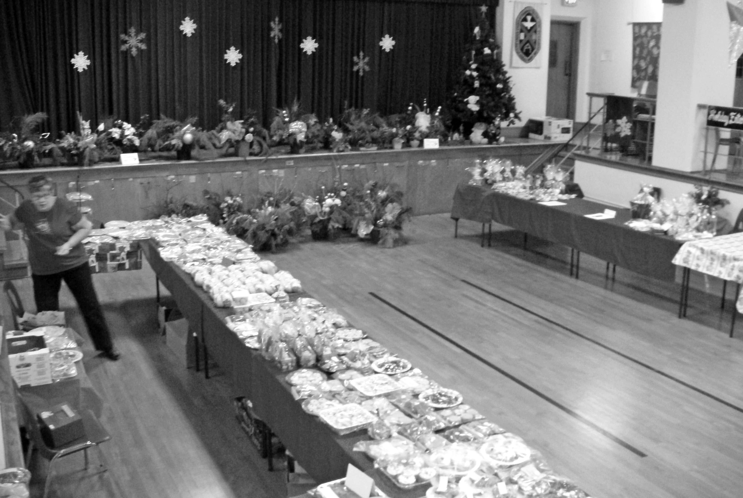
We celebrate another successful Holly Fair. Even with our congregation going through a big transition, the family of First United came through with great donations for our event!!
As the doors opened, anxious people were welcomed in to see what First United had in store for them this year. We continue to try and make our Fair a shopping experience and not your typical Holiday Bazaar! But without the many months, days and hours put in by many special people this great day would not have been a reality. .. So we say to all of those people, that we express our appreciation for the many ways you contributed to the success of our Holly Fair. Congratulations to all of you…This event raised $5400.00 for the General Fund.

A huge thank you to the Holly Fair Team whose support and friendship helped make this event possible. To the staff and volunteers for the many ways you all helped - we thank you. A special thank you to the youth that helped this year. It was great to have you as part of the team.
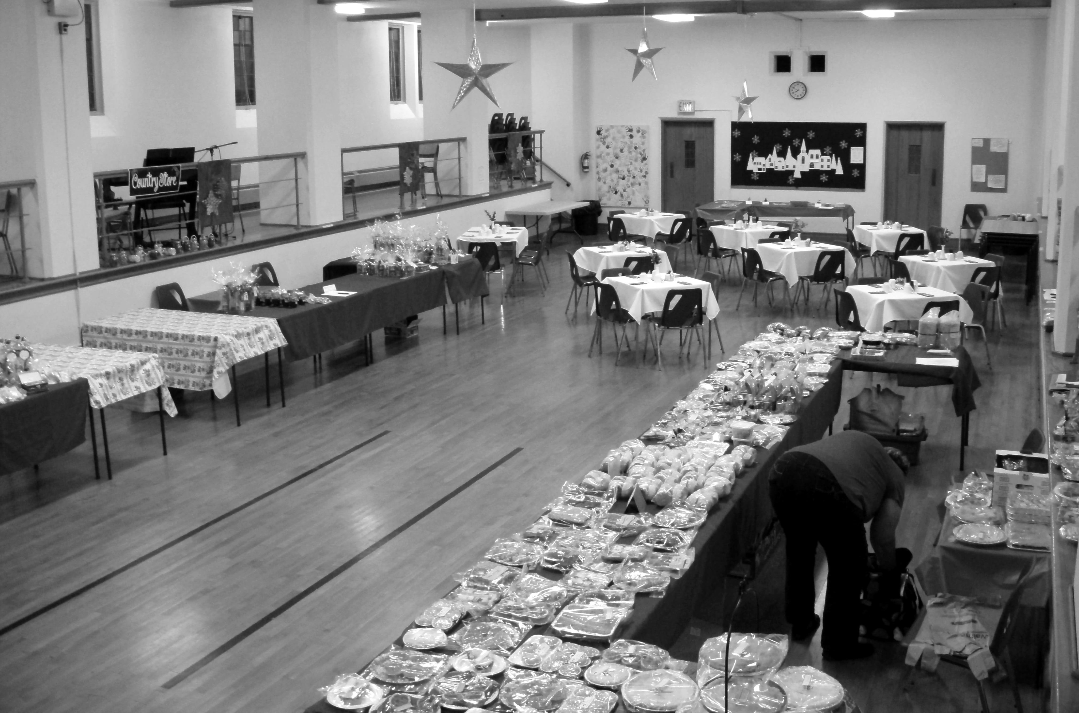

Sherry Johnstone, Lois Whiteman

2017 Holly Fair Convenor Team

Special Thank yous:

To those who helped set up and tear down…

Lois Whiteman/helpers.. such a valued team effort!

First United staff… Couldn’t have done it without you!

Thank you to Marlene Smith for her musical entertainment in the Café!

Thank you to Elizabeth (Biz) and Wade Thompson for the donation of greenery for our fresh arrangements. Thank you to Rosemary Underhill for donating her residence, pots and supplies to make the arrangements. Thank you to Lois Whiteman, Sheryl Haaijema, Marlene Smith, Sherry Johnstone, Rosemary Underhill and Carolyn Lapare for helping at the fresh arrangement bee. Great Job!
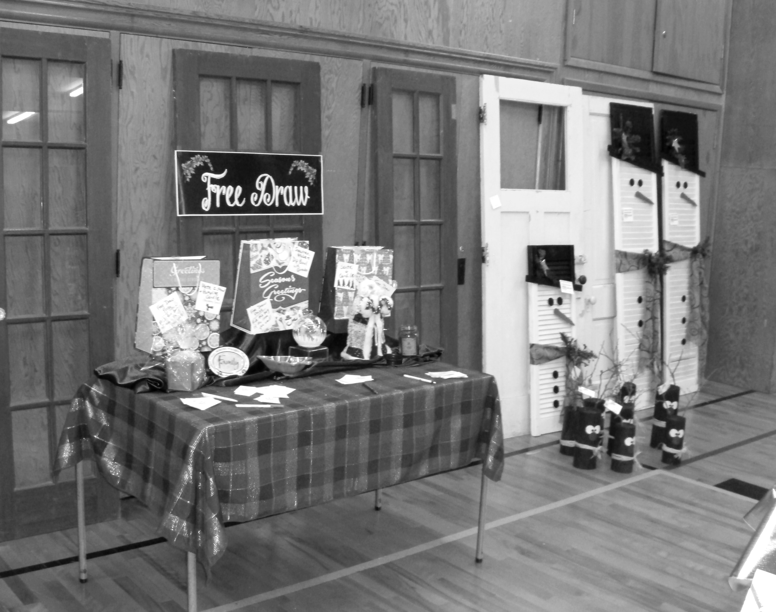

Some highlights of the event:

49 fresh arrangements – 39 Large + 10 small. All Sold thanks to Judy & Joe. (Greenery/embellishments donated – approx $1200-1300 profit.

Silent Auction raised $430.00 (Great auction donations!)

Audrey’s tea biscuits and pies were back!!!

Mini bazaars after church for 3 Sundays was a success.

($680 in sales as part of $5400 total)

Thank you to those who shopped after church.

Great children’s craft and ice fishing in Children’s area

New Holly Fair Café a great success – Takeout area to be larger in 2018

Holly Fair Team 2017
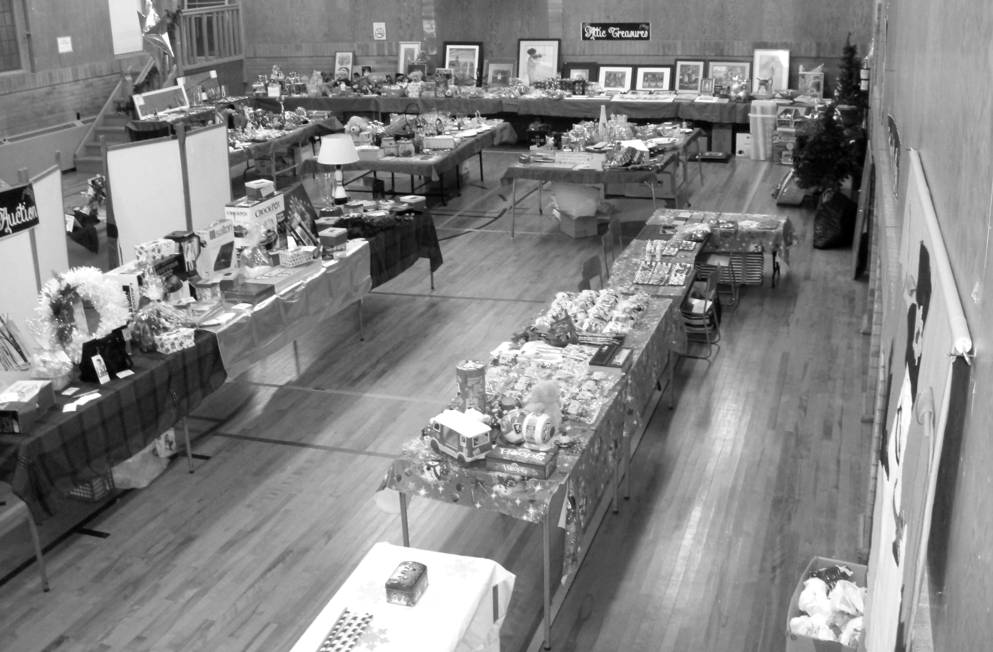

Mary Anne Rayner Holly Fair Cafe

Lois Whiteman Bake Shop

Sharlene Scott Deli

Betty Lou Donaldson Holiday Entertaining

Edith Nimmo/ Sharon Hutchison Book Store

Children’s Corner Kim Hughson/Ruth Zions
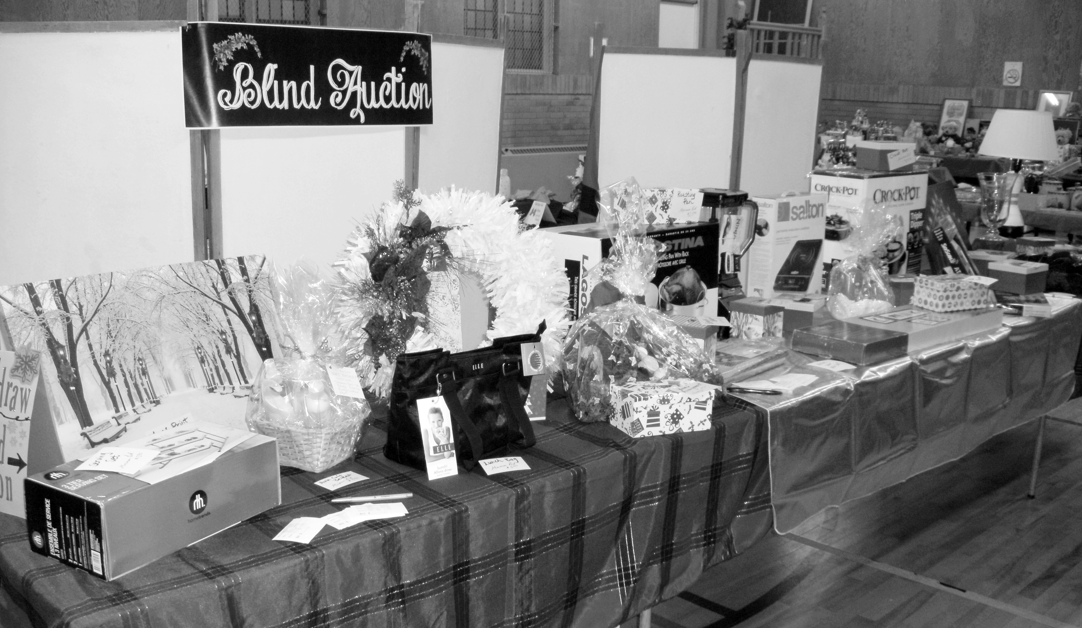

Attic Treasures Leslie Pipes

Sherry Johnstone Crafter’s Market

Sheryl Haaijema Silent Auction/Draw Prizes

Jacqui Travis Finances

Mark Snowsell Parking

Kathy Nicli/Congregation members Beautiful Overall Decorating

Sherry Johnstone Signs & Bulletin Boards

Vicki Snowsell Publicity

Some Thoughts for Spring/Summer (Items needed for Holly Fair 2018)

Christmas items for attic treasures

Children’s books – (gently read) Sticker books/coloring books in unused condition

Paper Gift bags – of any kind

Jellies/Jams/Preserves/Pickles/Chili Sauce/Antipasto *****

Gently used games/toys/stuffed animals/any dolls/hot wheels (dinky cars)

Jewelry/Crystal for Attic Treasures

Home Décor items/garden items

FUN, FUN Novelty kids items like purses, pillows, blankets, mittens, booties

Items for early – mid teens

Lots of handmade Christmas ornaments for our ornament tree (we’ll take good ideas too)

Mittens/Hats- all ages

These are just some item ideas to get you started………….

Holly Fair Note to the Congregation for 2018
Though we had such generous donations of many kinds from several in the congregation, of which we are so thankful for…we did have a decline in donations in all store areas of our event…
This event continues to be a popular event in our congregation as well in the community and this event will only continue to be the success it is, with the support of the First Families and the community. So we ask you to reflect from now until fall of this year, on how you can be a part of that vision. As great as this event is, we need everyone’s help to make it happen in whatever way you can.

2018- Help Specific
Need additional help for set up and tear down.
Donation of embellishments for our fresh arrangements
We could reuse items from any 2017 arrangements as well.

FIRST WITH THE NEWS

To make a submission, please contact Lori @ 631-7570 or email to firstunited@bellnet.ca

