**Join us Friday at 10:30am at First United for our Joint Good Friday Worship Service! All are welcome!**

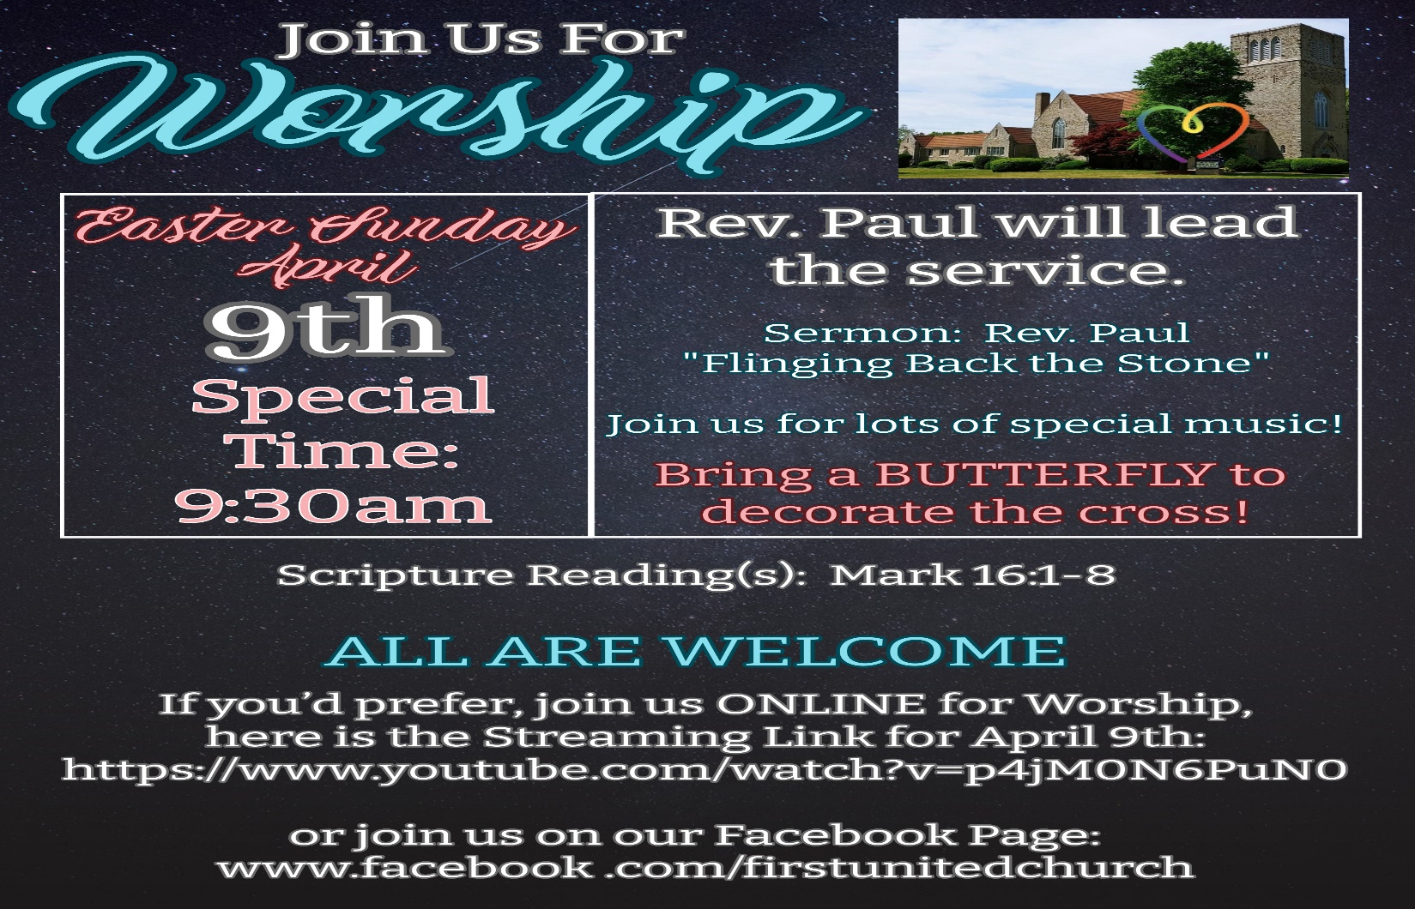

**Everyone is invited to join us Easter Sunday at 9:30am for our Easter Celebration!**

**REMEMBER to bring a BUTTERFLY to church with you (dollar store finds or handmade are perfect!). When you enter the sanctuary we will have friends there to direct you and we’ll decorate the cross before worship!**

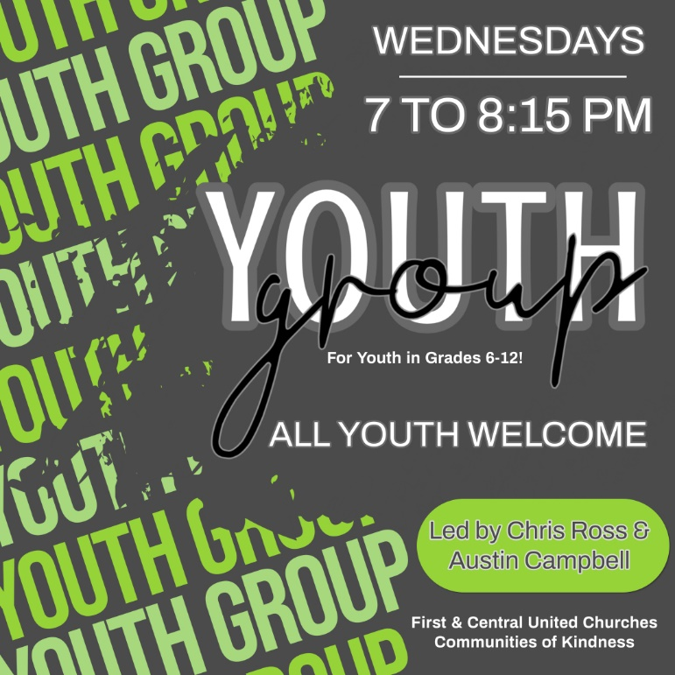



Google Form sign up link: <https://forms.gle/wXCovj9GguaTxaz86>

**Check out our Website & follow us on all our Social Media platforms!**

**Website:** [**www.1stunitedchurch.ca**](http://www.1stunitedchurch.ca)

**On Facebook: firstunitedchurch**

**On Instagram: @firstunited1834**

**On Twitter: @FirstUnitedStT**

**On YouTube: First United Church, St. Thomas**