**If you’d prefer, join us ONLINE for Worship,**

**here is the Streaming Link for Christmas Eve (7:30pm):**

[**https://www.youtube.com/watch?v=TGkSAbXtZgA**](https://www.youtube.com/watch?v=TGkSAbXtZgA)

**or join us on our Facebook Page:** **www.facebook .com/firstunitedchurch**

**Join us AT CENTRAL UNITED CHURCH Christmas Day at 10:30am!**

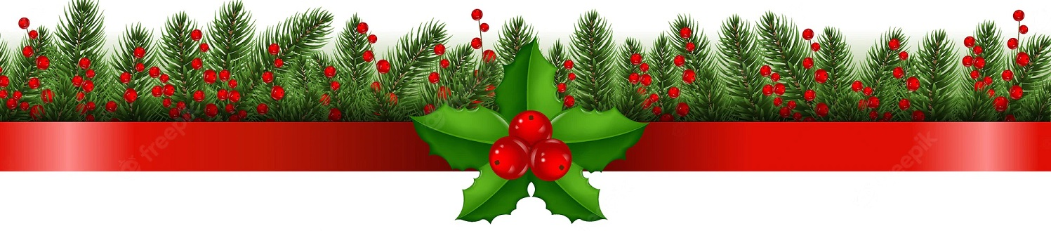

**If you’d prefer, join us ONLINE for Worship,**

**here is the Streaming Link for Christmas Day (10:30am):**

**https://www.youtube.com/watch?v=80RkhzUdPLo**

**With Gratitude…**

**Due to the generosity of Samuel Ivor many, many years ago, First United Church has made donations to:**

**Grace Café** **($1,000)**

**Inn Out of the Cold ($1,000)**

**and the St. Thomas-Elgin Food Bank ($1,000)**

**from the interest received by the Ivor Fund in 2023.**

**Happy Birthday to:**

**Sara Turner, Tom Beechey**

**Happy Anniversary to:**

**Bill & Sandra Arts**