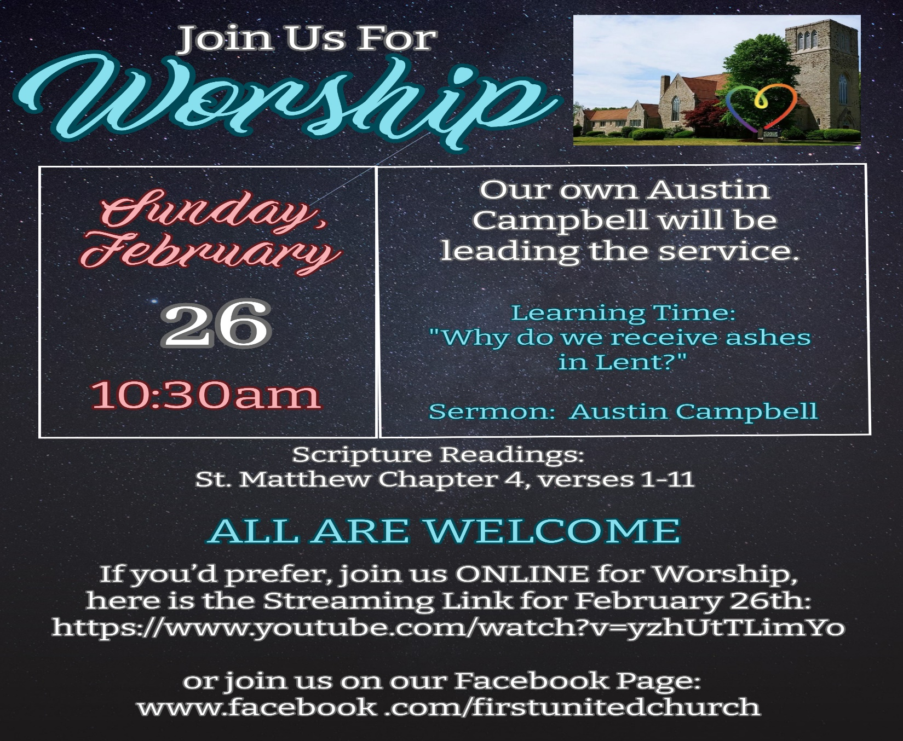



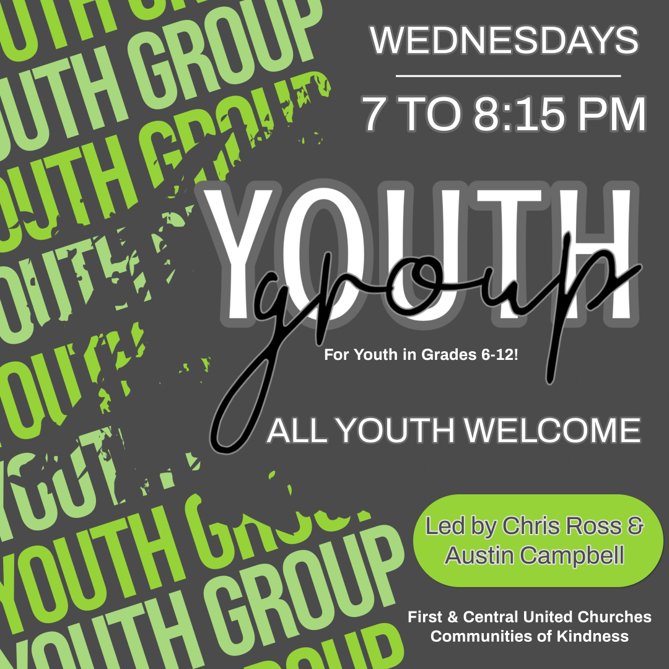

**Thank you**

**for supporting**

**the ministry of**

**First United**

**Church.**

**Our own “Minister of Fun” & Community Engagement, Austin Campbell will be the Camp Director!!**

**REGISTRATION FORMS CAN BE FOUND ON OUR WEBSITE!**

**www.1stunitedchurch.ca**

**Check out our Website & follow us on all our Social Media platforms!**

**Website:** [**www.1stunitedchurch.ca**](http://www.1stunitedchurch.ca)

**On Facebook: firstunitedchurch**

**On Instagram: @firstunited1834**

**On Twitter: @FirstUnitedStT**

**On YouTube: First United Church, St. Thomas**