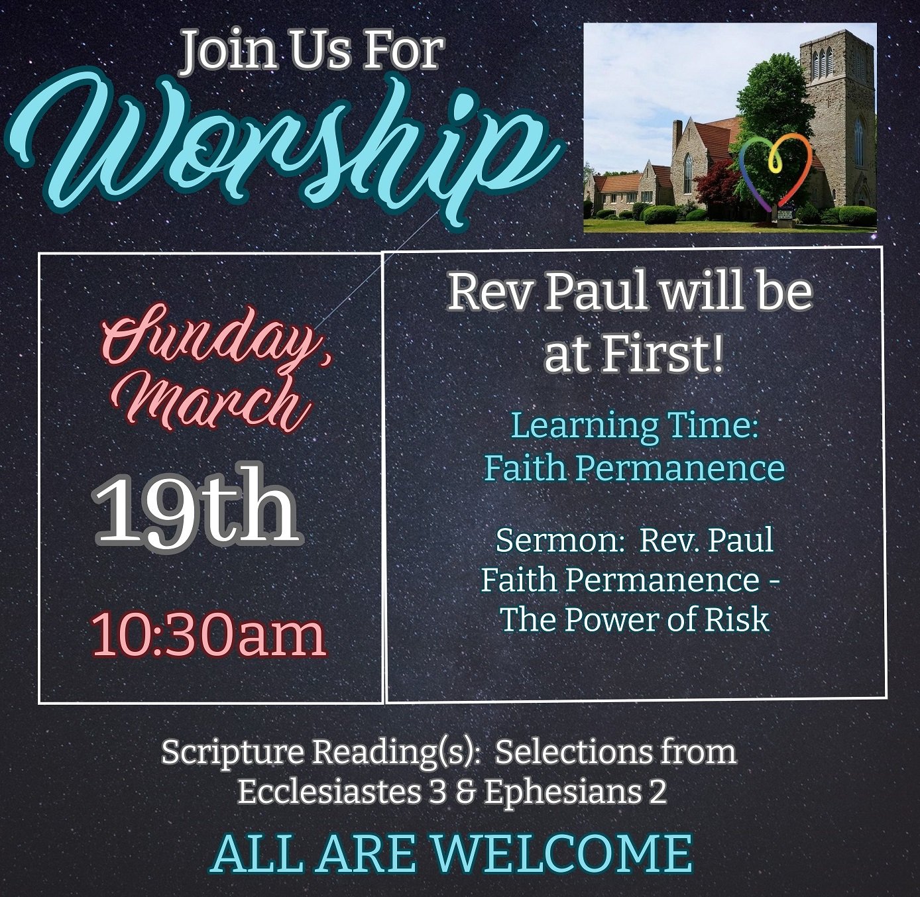

Our own Mike Muma’s partner, Cheryl, is actively

involved in providing meals in the community.

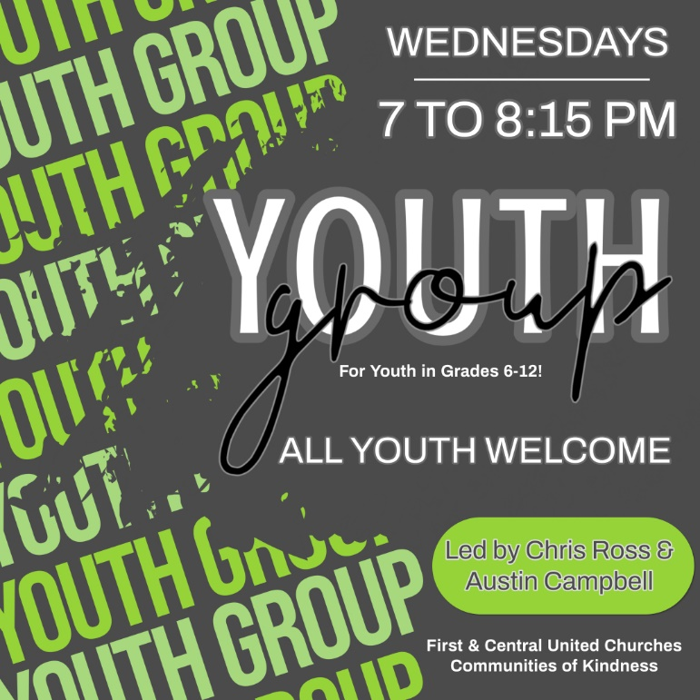

**Check out our Website & follow us on all our Social Media platforms!**

**Website:** [**www.1stunitedchurch.ca**](http://www.1stunitedchurch.ca)

**On Facebook: firstunitedchurch**

**On Instagram: @firstunited1834**

**On Twitter: @FirstUnitedStT**

**On YouTube: First United Church, St. Thomas**