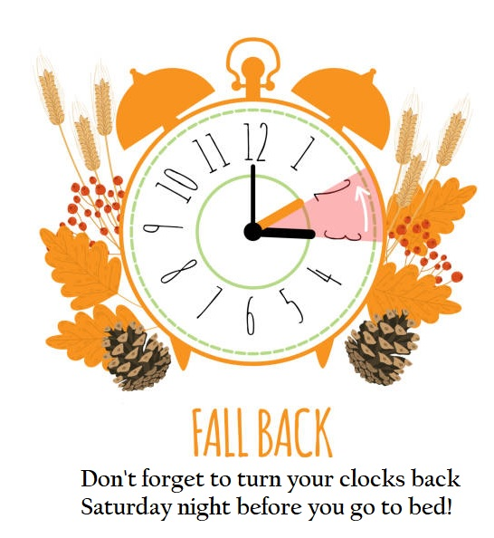

**Happy Birthday Wishes**

**June Harris**

**Don Gagen**

**Brian Wilsdon**

**Clare Beamish**

**Bill Turvey**

**Everyone is invited to join us at CENTRAL UNITED CHURCH,**

**135 Wellington Street on Sunday Morning at 10:30am for “Remembrance Sunday”.**

(First United’s building is closed)

**Scripture: Ephesians 6:11-18**

**Sermon: “Overcoming the Dark Side” - Rev. Paul Browning**

**If you’d prefer, join us ONLINE for Worship,**

**here is the Streaming Link for November 6th:**

<https://youtu.be/1TGK8zh5Tss>

**

