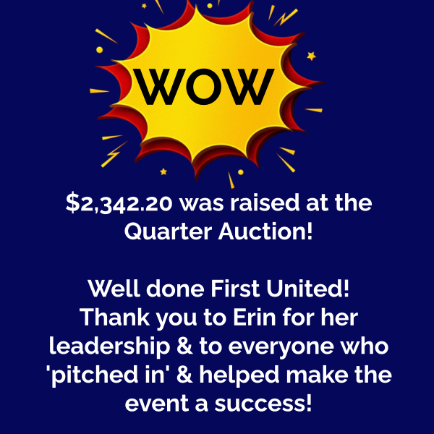

**A Pre-Advent / Christmas Newsletter**

is going out on November 19th.

If your group / Committee has something you would like to have included please have it in to Lori **by 11:59pm on Sunday, November 12.** (office@1stunitedchurch.ca)

(No late submissions will be accepted due to the short turnaround time for the Newsletter).

Thank you!

**If you’d like to help with the event, please contact Mark & Vicki Snowsell at snowsell@rogers.com**

Continued next page …

**