**Everyone is invited to join us**

**at FIRST UNITED CHURCH on**

**Sunday Morning at 10:30am**

**We hope everyone will join us Sunday Morning for Worship.**

**Rev. Donna Kerrigan will be our guest preacher.**

**Family Time: “Colouring Your World”**

**Scripture Lesson: Luke 18:9-14**

**Sermon: “Humble Toward Heaven”**

**The Band & Choir will lead music**

**If you’d prefer, join us ONLINE for Worship:**

**Here is the Streaming Link for October 23rd:**

<https://www.youtube.com/watch?v=XFIXdm2Iqq0>

or join us on our Facebook Page: www.facebook.com/firstunitedchurch

**Happy Birthday Wishes**

**Austin Campbell**

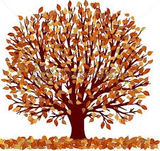

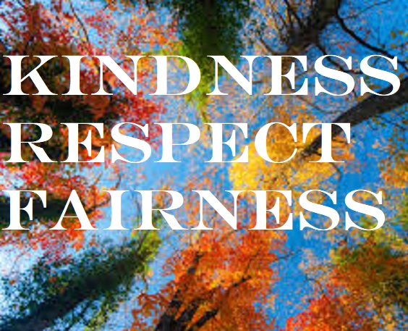

**October 30th**

**Invitation to Wear a Halloween Costume of Some Kind**

**From the beginning of the Jesus movement until the 13th century, Christianity blended well with indigenous religions like Pagan spirituality in Europe. This is why we share the same Holy Days with different names.**

**October 30th is the Sunday before All Hallowed Eve and the feast of All Saints, two sides of the same coin. It’s a joy to rediscover important parts of our culture and religion that have been misplaced and lost such as Halloween.**

**While Halloween is mostly a secular celebration today, its increasing popularity strikes a chord within many people that reflects its ancient role as a deeply religious experience of overcoming the fear of death.**

**Our ancestors gathered at night (all hallowed or holy eve), on the first day of winter, to give thanks and take comfort that death gives way to life and that their deceased loved ones were still present with them in spirit, to help them make it through the cold and dangerous season they were facing. Jack-o-lanterns are the remnants of those early fires.**

**It was a joyful service, usually outdoors in the woods, with singing and dancing and**

**costumes to represent the ancestors whose love and presence were with them and whose spirits would help them survive their hardships.**

**The next morning, on All Saints Day, they went to church and celebrated the same thing indoors with another form of worship.**

**Everyone is invited**

**to join us at**

**FIRST UNITED CHURCH**

**on Sunday Morning at 10:30am**